Prior to participating on a team from East Duplin High School athletes must provide the Athletic Department with current address, emergency contact, insurance, medical alert and health history information. To expedite this process East Duplin High School ses an online data entry system. If you have internet access at home, you can begin this process as soon as possible. If not, you can come to the school on designed days (coaches will tell you) to fill out your information.
Request to join are accepted once a day. Please allow 24 hours before you send another request.
To enter your information, visit www.swol123.net. The first time you visit the website you will need to enter your email address and click Get Password.

Joining SportsWareOnLine
Instruction | Example
Go to www.swol123.net.
Scroll to the middle of the screen and click the Join SportsWare button. | 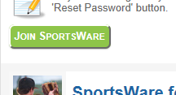
Enter your School ID

panthers18
Enter your First Name, Last Name, Email address and click the Send button.

Your request to join SportsWare will then be sent to the Athletic Trainer for review. | 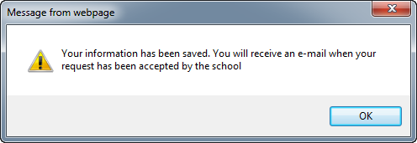
Once your request is accepted you will receive an e-mail with the Subject “SportsWare request accepted”.

Open the e-mail and click the www.swol123.net link to continue to SportsWareOnLine.

Setting Your Password
Instruction | Example
Go to www.swol123.net
Enter your Email Address and click the Reset Password button.
You will receive and e-mail with the Subject “SportsWareOnLine Password Request”.  Open the e-mail and click on the link to reset your password. Enter your e-mail address, new password and click the Save button. | 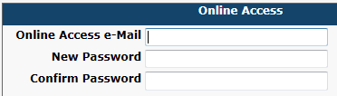

Updating Your Information
Instruction | Example
Go to www.swol123.net
Enter your Email Address and click the Login button.
At the top of the page is the Menu Bar.

My Info: Update your address, emergency contact and insurance information.

Med History: Complete a Medical History questionnaire.

Forms: View/complete required paperwork. Note: SportsWare will also display “You have 8 forms to complete”

Print: DO NOT PRINT ANY ITEMS. SAVE AND SUBMIT THE 8 FORMS.

Thank you for your prompt help. If you have any questions, please contact the school at 910-298-4535 for assistance.

Sincerely,
Heather Houston
EDHS Athletic Trainer

