David Viegas
Director of Health, Physical Education and Athletics

GEORGE W. HEWLETT HIGH SCHOOL
60 Everit Avenue
Hewlett, New York 11557-2136
Telephone: 516-792-4021/4022
Fax: 516-374-1921

In order for our teams to properly prepare, it is expected that all student athletes be in attendance on the first day of tryouts/practices and throughout the season, including holiday and recess periods.

Please read the following information carefully:

- All families are asked to create an account, register their child, and desired sport on Family ID. Family ID can be accessed HERE:

- It is imperative that any student interested in playing a sport register by the closing date. Students who fail to register by the deadline MAY BE denied participation, run the risk of not meeting the NYSPHSAA practice requirements, and the HWPS approval process to meet participation eligibility criteria.

- Please note that registration DOES NOT indicate your child has been approved. Families can view their approval status by doing the following:
- Log in to your Family ID account.
- On the blue bar at the top of the page, click Registrations.
- Next to your registration, click Summary.
- If an approval status has been added to the program, it will appear at the very bottom of the summary.

- If your child has not been approved, an email will be delivered through Family ID. Please do not call the nurse’s office- please make sure your email address is correct.
- No paper forms will be accepted. All forms MUST be uploaded through Family ID.

- When registering on Family ID, all information must be completed and acknowledged by the parent and athlete, including a health history and COVID-19 history.

- All Sports Physicals must be completed, dated, signed, and stamped by your doctor on the official New York State Physical Form, which should be dated within one year from the starting date of the desired sport. All physical examinations for school are to be documented on the NYS Required Health Examination Form. No other physical examination form will be accepted. Physical forms must be filled in completely and cannot be filled in with “see attached.” Only immunization records may be attached to physical forms. The examination form needs to indicate that the student can participate in all activities without restriction. All forms need to be uploaded on Family ID.
(Please see sample below).

- The Sports Update form is only valid for one month. Please do not sign, date, or submit the Sports Update form earlier than one month prior to the starting date of the desired sport. These forms can be found on Family ID or at: www.hwbulldogs.com

- As with any illness, students are not permitted to participate while ill. Any student diagnosed with COVID-19 must receive a medical reassessment and clearance to participate in sports from his/her physician which must state “cleared to return to sports post COVID-19.”
Once a student has been cleared for participation following a positive COVID-19 diagnosis, each incidence of prolonged absence will be reviewed individually by the nurse, coach, athletic trainer, and the athletic director. Each student will undergo a minimum three-day return to play evaluation. This will be done in consultation with the school athletic trainer, nurse, and/or physician, when necessary. A reasonable amount of practice time and playing time will be established based on the athlete's readiness for safe return to competition.

- HHS ONLY: When advancing to regional and state championship play, school administration must immediately notify the NYSPHSAA Executive Director of any confirmed COVID-19 positive case or close contact (as defined by the Department of Health) impacting a member of their team. Any members of a team who have tested positive will not be permitted to participate in NYSPHSAA Regional and/or State Championship events until properly cleared by Department of Health officials and will not be permitted entrance into any Regional or State Championship venue. If the member school determines it is unable to continue participating in a NYSPHSAA Regional and/ or State Championship event, it shall be the responsibility of the NYSPHSAA Executive Director to determine if there is a reasonable amount of time and interest to replace the impacted team/individual and which team/individual will be invited in accordance with NYSPHSAA bylaws (Rule 19. Penalties b. 1 & 2). If a replacement can be invited, that team/individual will be inserted into the bracket or event position vacated.

- It is important to note that our athletes will follow all facility requirements including those that mandate COVID-19 vaccinations. Students may be denied opportunities to participate if they cannot adhere to the requirements of those facilities.

- Athletes must wear masks when participating indoors. NYSDOH guidance does make some accommodations for indoor sports where masking is not possible, but with the caveat that individuals must be distanced 6 feet apart, but otherwise participants must wear masks. Masking is not required for outdoor sports. Unlike some prior guidance, CDC’s most recent masking guidance does not make an exception for school sports/activities where masking may not be “tolerable” to a participant, unless the participant has an ADA recognized disability.

- Additionally, it is at this time that we ask Hewlett High School families to prepare in advance and understand that many high school athletic events take place on SAT/ACT testing days. Please notify coaches in advance if your child will be absent due to testing.

- Each student participating in a co-curricular activity must acknowledge an “Eligibility for Co-Curricular Activities Statement of Understanding.” Access the eligibility regulations HERE.

Sample NYS School Health Examination Form
(As of January 31, 2021, physical examinations for school are to be documented on the NYS Required Health Examination Form (see below):

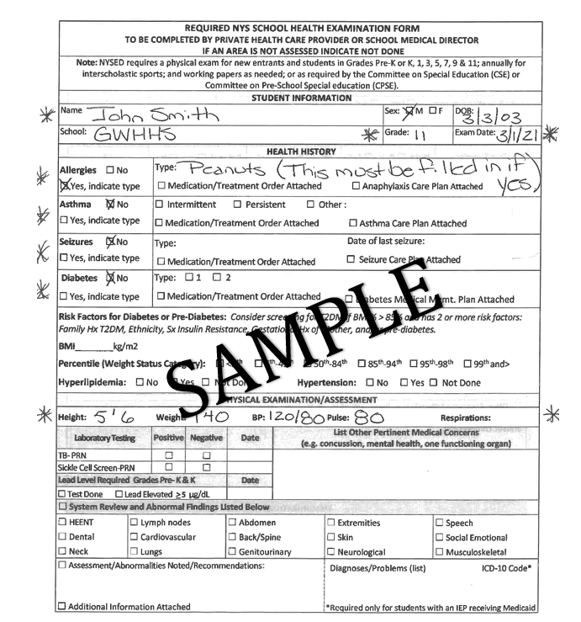

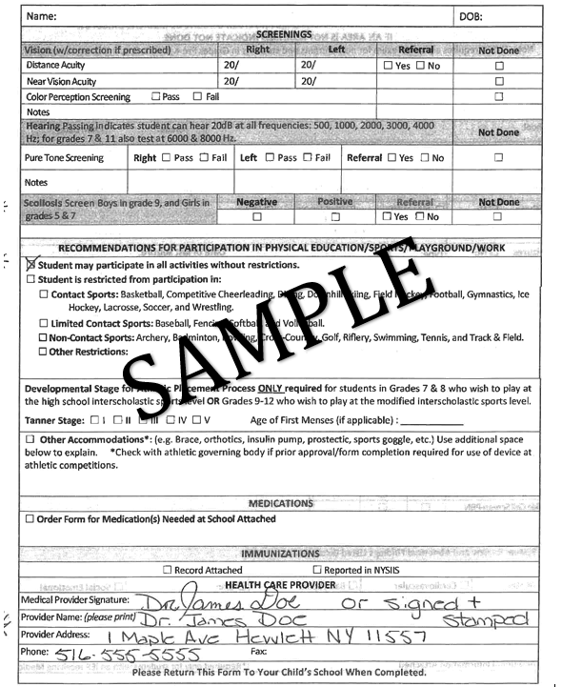

If you have any questions please call:
- G.W. Hewlett High School Health Office (Janice Nolan, R.N.) @ (516)-792-4110
- Woodmere Middle School Health Office (Lori Bromley, R.N.) @ (516)-792-4310
- Hewlett-Woodmere Public Schools Department of Health, Physical Education and Athletics @
(516) 792-4021.

We look forward to seeing your children on the fields of play for Winter Sports. Go Bulldogs!

Sincerely,
David Viegas
Director of Health, Physical Education and Athletics

