11th Annual MULCH MADNESS Fundraiser
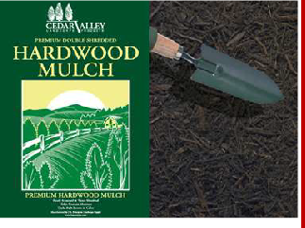
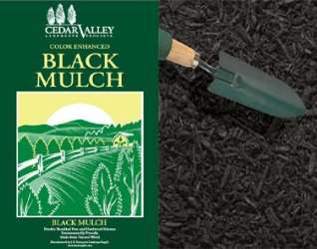
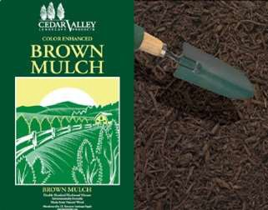
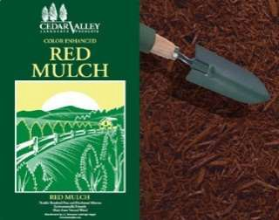
Orders Due: March 8, 2024 Delivered on: March 16, 2024
PREMIUM DOUBLE SHREDDED HARDWOOD MULCH
Finely screened double shred Helps contain moisture Helps suppress weed growth
Dark, rich natural brown color
3 cu ft bag 45 bags per pallet
Long lasting resilient vibrant color Double Shred hardwood mixture Environmentally friendly
Made from Natural Wood, no previously processed wood waste
2 cu ft bag 70 bags per pallet
COLOR ENHANCED MULCH
RED
BROWN
BLACK
Purchaser’s Information
Name
Address
City/State
Subdivision
Phone
Email
Delivery will be made within 7 miles of Patriot High School. Orders outside that limit must be picked up by the purchaser at the school. Purchasers outside
the limit will be notified.
Delivery Address (if Different from Above)
Address
City/State
Subdivision
Student Selling Mulch
Group Student Represents

Estimated Mulch Coverage Chart
Area to Cover | 2” Depth | 3” Depth | 4” Depth
5X5 or 10 X 2.5 | 2 bags | 3 bags | 4 bags
10X10 or 5X20 | 8 bags | 12 bags | 16 bags
10X20 or 5x40 | 16 bags | 24 bags | 32 bags

Mulch Order Information
Mulch | HDWD | BLACK | BROWN | RED
#Bags
#Pallet(s)
Total Amount Due: $
Please Circle Type of Payment
Cash Check CC

Pricing Chart
8 bags | $5.00 | $40.00
12 bags | $5.00 | $60.00
32 bags | $5.00 | $160.00
Pallet Hardwood - 45 bags | $5.00 | $225.00
Pallet Colored - 70 bags | $5.00 | $350.00
Make Check Payable to PHS Booster Club
OR
Order & Pay Online at:
Patriot Mulch Sale or access by https://patriotpioneers.square.site

Patriot Pioneers Booster Club, Inc. 10504 Kettle Run Road Nokesville, VA 2018

Patriot Pioneers Booster Club, Inc. is a registered 501 C-3 Non-Profit Organization www.patriotpoineers.org/boosters

