Parent Concussion Education Walk-through
Step 1: Type www.fcps.edu/sports in to your web browser and the following screen will appear
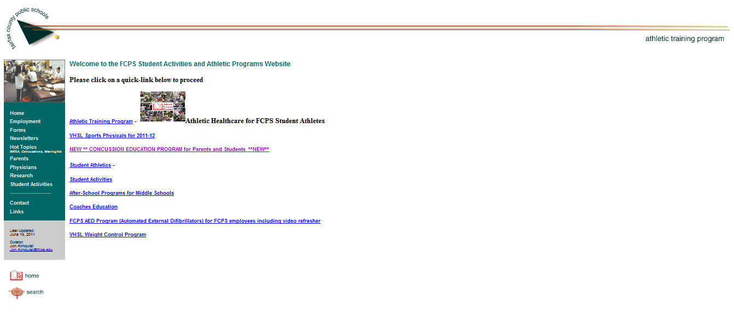
Step 2: Click on ”NEW ** CONCUSSION EDUCATION PROGRAM for Parents and Students **NEW**”
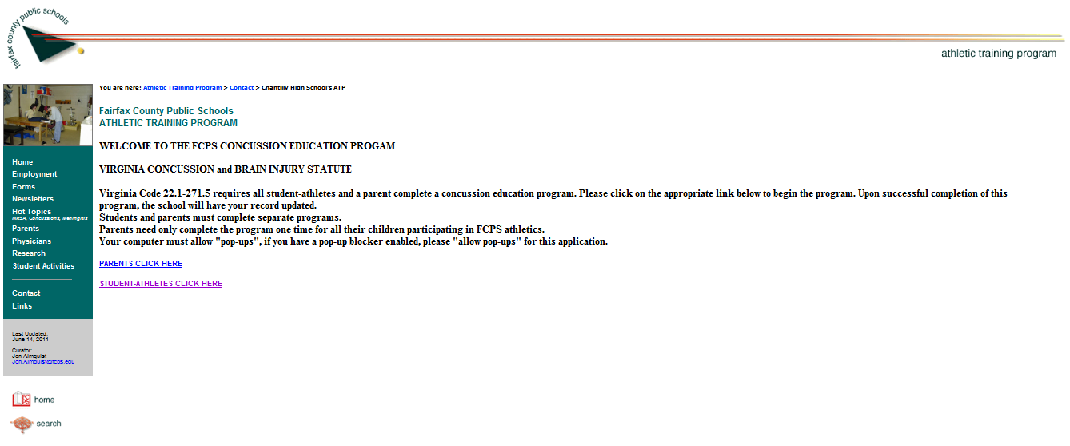
Step 3: Click on “PARENTS CLICK HERE”
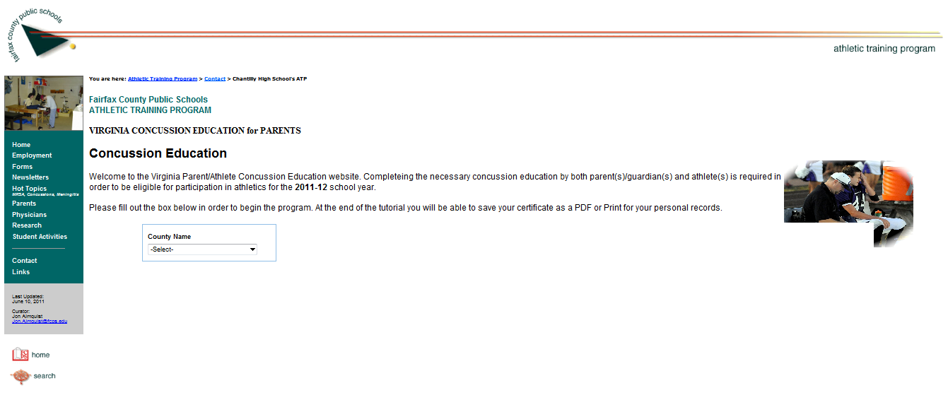
Step 4: Select “Fairfax County Public Schools” under County Name scroll
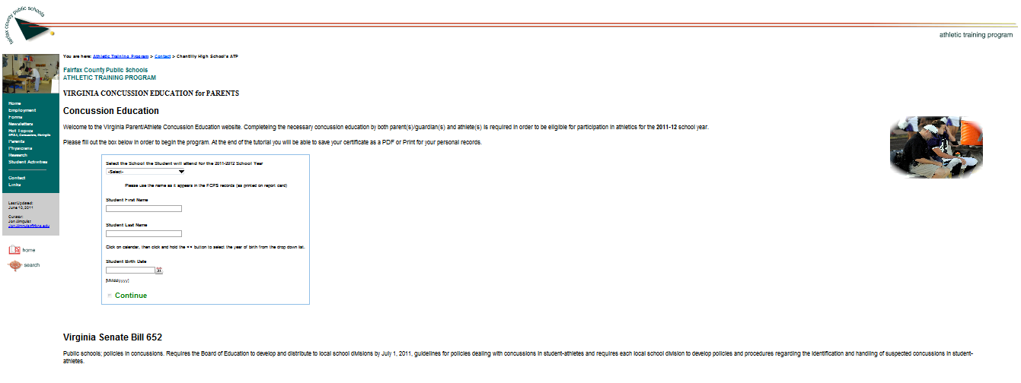
Step 5: Select the school your son/daughter will be attending
Step 6: Type in your son/ daughter’s first and last name
Step 7: Type in your son/ daughter’s date of birth or use the calendar for your convenience (make sure it is in the proper MM/DD/YYYY format)
Step 8: Click “Continue

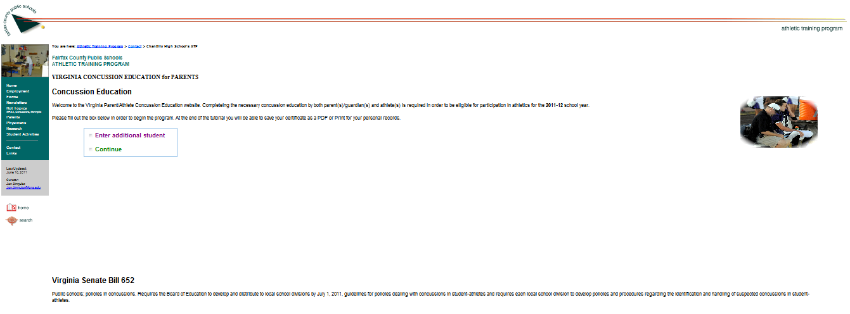
Step 9: If you have more than one student attending school click here and repeat steps 5-8
If only one student, click here

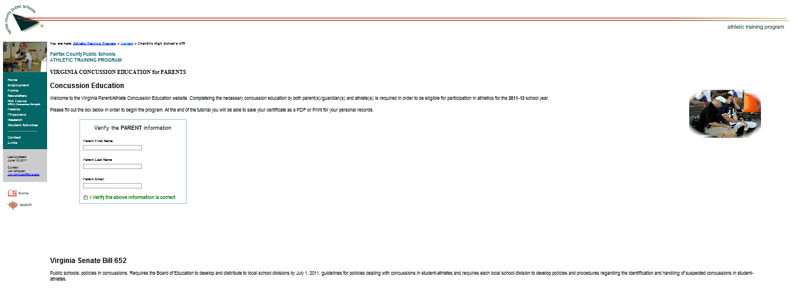
Step 10: Enter your first and last name as well as email address here to verify correct information
Step 11: Click here to submit information

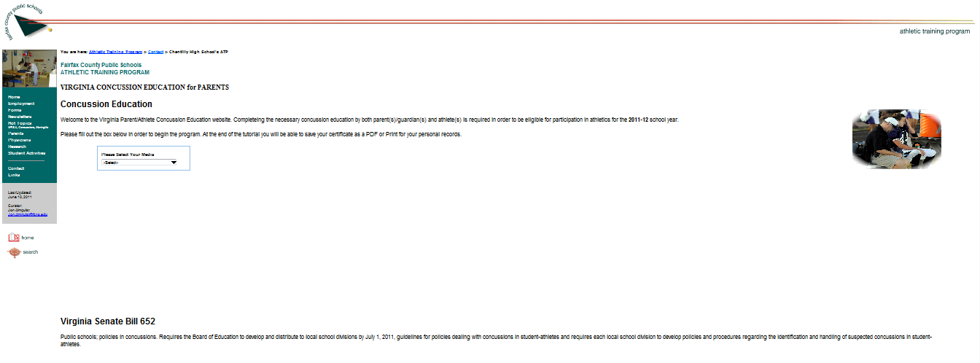
Step 12: Select media type you would like to use
Step 13: Chose the slideshow option, read slides until presentation is complete

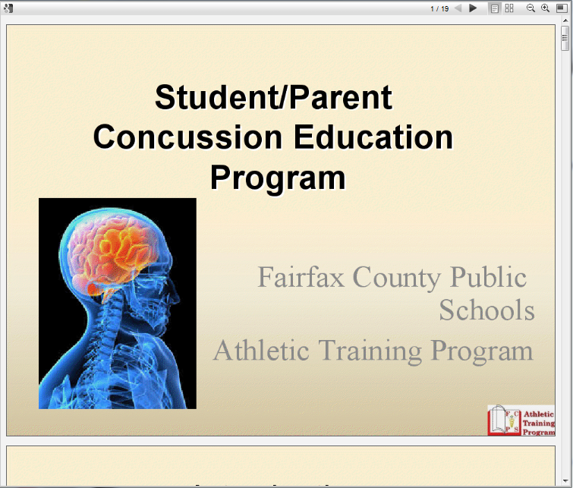
Step 14: Advance slides by clicking à or scrolling down
Step 15: FOLLOW DIRECTIONS CLOSELY TO EXIT SLIDESHOW
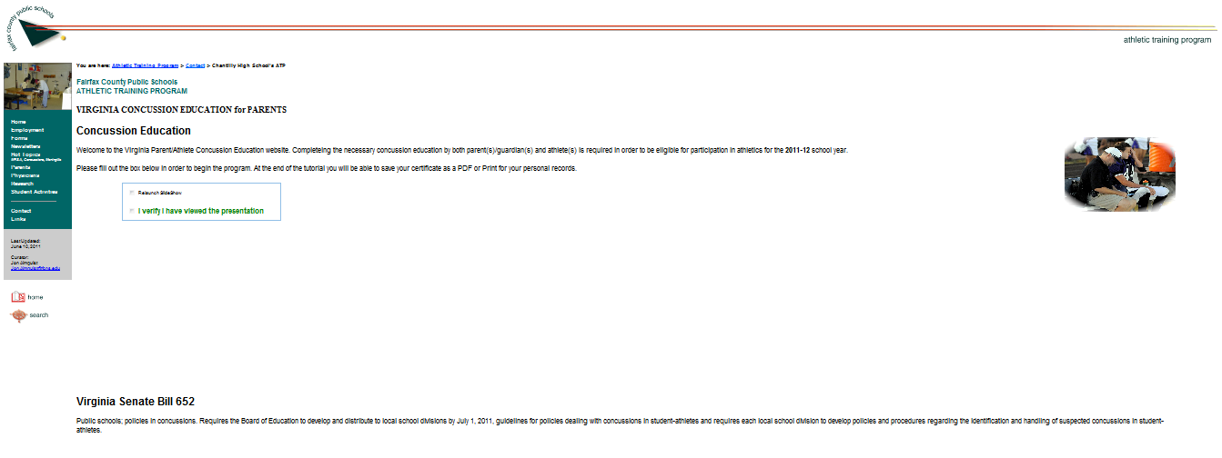
Step 16: If you need to view the slideshow again click here
Step 17: To complete concussion education course click here
Step 18: Print education verification if desired (optional). The system has electronically recorded that you have completed the Concussion Education Program

