Cougar Athletic Boosters

september 2017
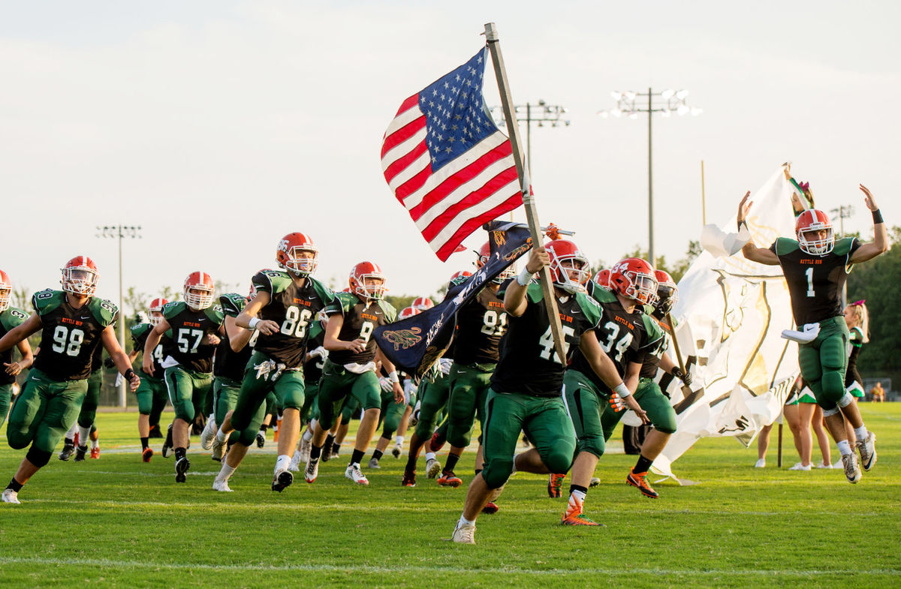  Back to School  Over the past few weeks, a tremendous amount of hard work has been put into starting the 2017-2018 season off strong. Our Committee Chairs have done an awesome job! Co-Chairs Lisa McIntyre and Julie Richards new designs and ladies’ line of Spiritwear have been selling like gangbusters. Check it out or let them know if you have any requests. Kari Schwind, New Membership Chair, continues signing up new members. If interested in a membership go to www.KettleRunSports.org website and click on the “Boosters” to explore the possibilities. The Boosters’ have worked tirelessly so inside and outside concessions are fully stocked for all events. We have added some new items and Meal Deals to help make your experience delectable. So, bring your appetite!  Some of our fundraising highlights this past month were school fee days, the football scrimmage, and our first home football game against Manassas Park. We are so proud of our early fundraising successes. With such a positive and promising start to our fundraising, we can't wait to see what the rest of this year will bring.  SEE YOU AT THE GAMES! GO COUGARS!!!! | Upcoming events  Next Meeting:  **CHANGE FROM NORMAL DATE**  Our next meeting is September 7 at 7 p.m. in the Library. Due to athletic events, this date is a change from our regularly scheduled meetings that are held on the second Thursday of every month. All members are always welcome!!  athletic events:  9/1 Football @ Home 9/6 JV Football & Volleyball @ Home 9/12 Volleyball @ Home 9/13 JV Football & Volleyball @ Home 9/14 Field Hockey @ Home 9/19 Volleyball & Field Hockey @ Home 9/21 Volleyball & Field Hockey @ Home 9/22 Homecoming Football Game 9/26 Field Hockey @ Home 9/29 Football @ Home  Volunteers  Please join us in the effort to continue to raise funds for our student athletes. We are always in need of Volunteers! As a token of our appreciation for volunteering, all Volunteers, while working, may enjoy a food item (hamburger, hot dog, or a slice of pizza), a bag of chips or box of popcorn, and a drink. Contact the Boosters at cougarathleticboosters@gmail.com to see where you can help. We always have fun so come join us!

