RICHARDS MIDDLE SCHOOL
FAMILY ID
REGISTRATION INSTRUCTIONS

FamilyID is a secure registration platform that provides you with an easy, user-friendly way to register for our programs, and helps us to be more administratively efficient and environmentally responsible. When you register through FamilyID, the system keeps track of your information in your FamilyID profile so you enter your information only once for multiple uses, multiple family members and multiple programs.

BEFORE YOU REGISTER

ELIGIBILITY: A first time 7th grade student may compete without reference to his/her record in the previous grade; but a student who repeats grade 7, or is in 8th grade, is subject to previous semester academic requirements.

PHYSICAL EXAMS: A physical exam must be current (since April 15, 2023) and signed by the physician. All other sections of the physical form must be completed by parent/student.

INFORMATION NEEDED TO REGISTER

It will be helpful to have your doctor and health insurance information, along with names and phone numbers for all of your emergency contacts to allow for accurate completion of your online registration.

A parent/guardian should register by going to the following web site:

https://students.arbitersports.com/organizations/5089/programs

Follow these steps:

- Under the "Programs" title, click on the link for the program you want to sign up for. Scroll to bottom of page to either Sign Up if this is your first time using FamilyID, or Log In if you already have a FamilyID account.
- Sign Up for your secure FamilyID account by entering your family name, email address and password. You will receive an email with a link to activate your new account. (If you don’t see the email, check your spam or junk folders.)
- Click on the link in your email activation, which will log you in to FamilyID.

- If you do not return to the registration form, click 'Find Programs' to retrieve the form.

- Once in the registration form, complete the information requested. If you have registered for a sport in a previous season, there is a button that says, “Click here to SELECT or CREATE participant”. Click on that button and choose the participant you are registering; it will fill in the information entered previously (PARTICIPATION INFORMATION shown below). Scroll through and make sure that all sections are filled in, check for accuracy, make any necessary changes, and make sure you complete all of the Agreements.

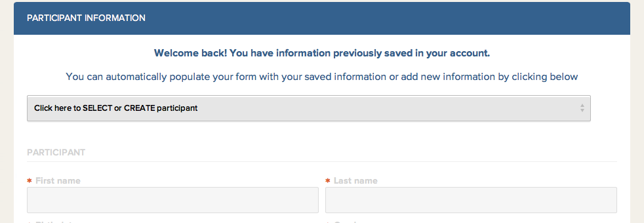

- When you have completed the form, click the “Save & Continue” button.

- You will be directed to the SUMMARY page as pictured below. You must click the green “SUBMIT” button for your registration to be complete.

Family ID does not accept or track Pay to Participate payments. It will always show that you owe a balance of $30.00 whether you have paid or not; payments are registered in the athletic office only.

If you need assistance with your registration, you can call FamilyID at 800-311-4060 or email support@arbitersports.com.

Please call the Athletic Office at 586-439-7252 if you have any questions regarding registration.

THANK YOU AND GO KNIGHTS!!

