NFHS “Concussion in Sports” Walk-through

- Goto NFHS website: http://nfhslearn.com/index.aspx
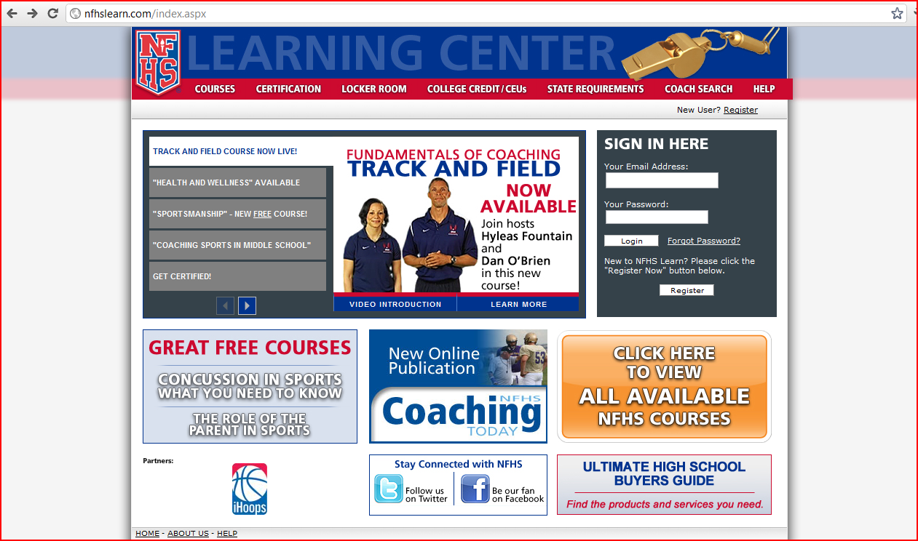
- Click the “Register” link. This is how the NFHS tracks your course attendance and how we will verify your completion of the course.
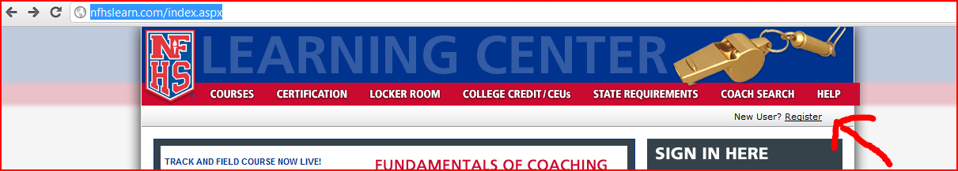
- On the Register as a New User page, fill in as much information as you can. You will need to provide an email address. When you get to this section, please use the drop-down box to fill in “parent” or “athlete.” School District is FCCPS. Schools is George Mason High School, Falls Church, Va.
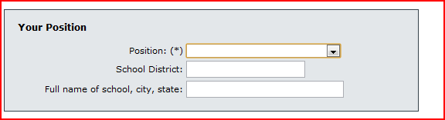

- After you register and login – click on the Concussion in Sports link:
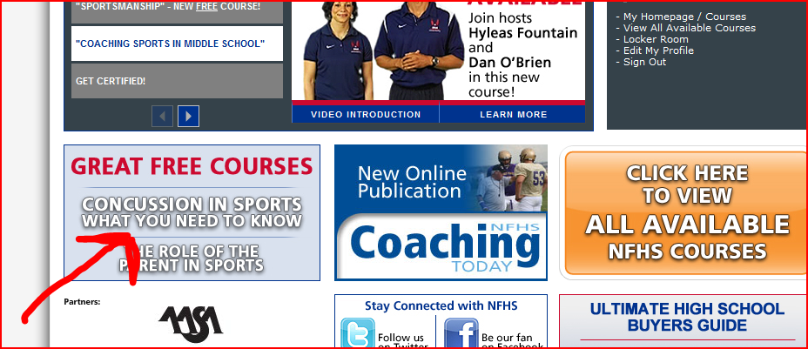
- Click “Order Now” – don’t worry, it is free.
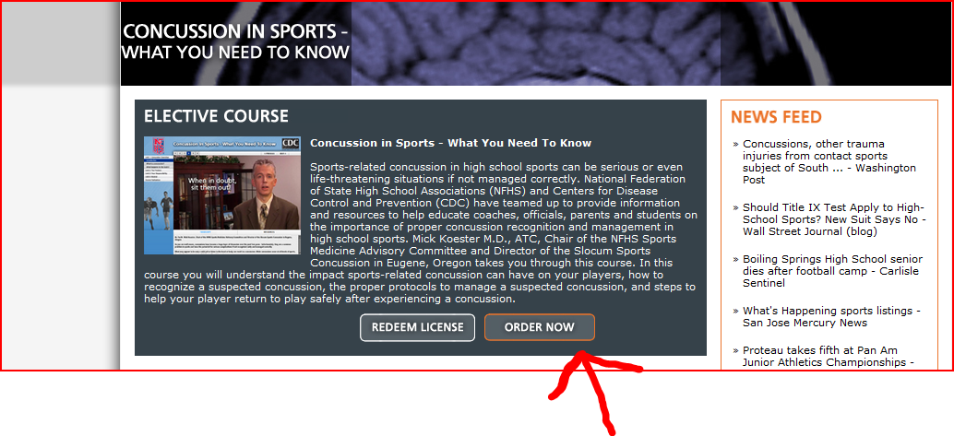
- 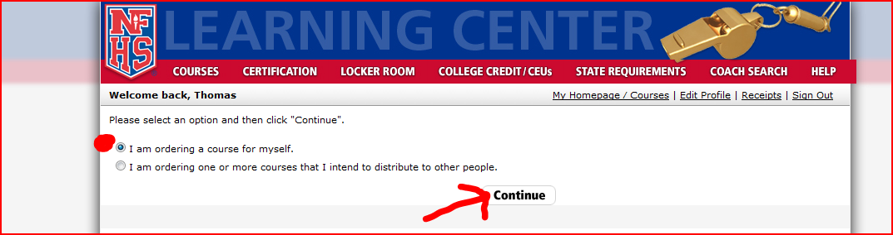

- Be sure you list state as “Virginia” and CLICK SAVE before going to “Checkout”

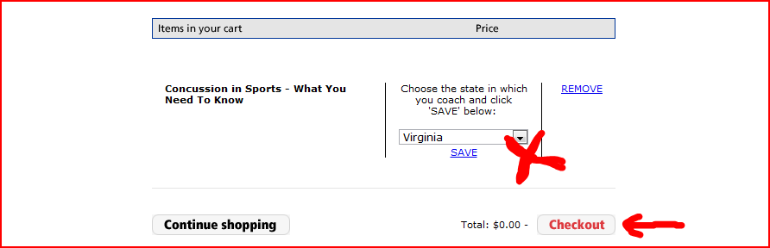
- Complete Purchase.
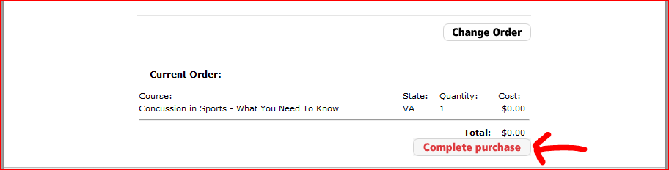
- Click this link to go to your courses.
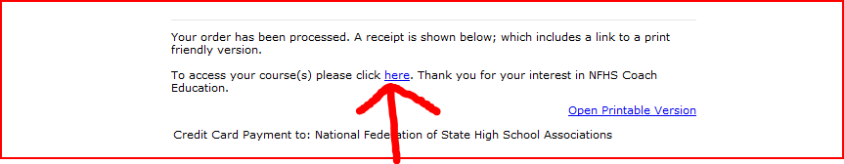

- Click “Begin” to start your course.
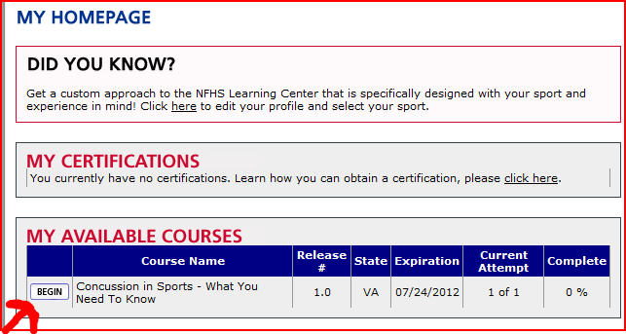
- The course will open in a new window. The site will track your progress and you can logout and return to the point where you exited.
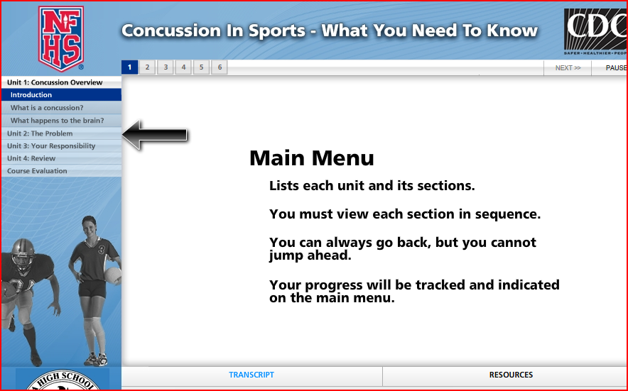

- When you finish the course you will see this screen!! Congratulations!
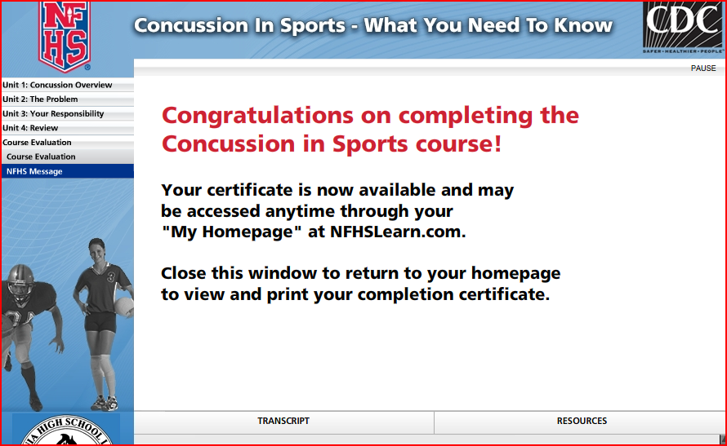
- At this point please print our Acknowledgement form, sign, and return! The form can be found here: http://www.masonathletics.org/library/files/masonathletics/files/ConcussionTrainingAcknowledgement.doc

