Southwest Guilford High School
Athletic Booster Club
2022-2023
Capital Fund Committee
Request for Proposals

Southwest Guilford High School
Athletic Booster Club
Capital Fund Guidelines
2020-2021
The SW Athletic Booster Club - Capital Fund seeks to partner with its secondary booster clubs to fund projects that will help our players and coaches succeed. To that end the Capital Fund is looking to support projects that will bring a positive return on investment to SW Athletics by the following:
1. Returning money to us. (i.e., Buy a popcorn machine and make money)
2. Minimizes costs to the Athletic Department or booster club. (i.e., Spend money on a power washer and use volunteers rather than hiring someone to do the work.)
3) Builds SW Athletics enthusiasm/SW Brand Awareness (logo on the field restroom, wrapping the gator in SW logo, assisting students with buses for playoff games)
4) Encourages the raising of matching funds to achieve more with less. The capital fund is looking to support projects at a 50/50 split level unless the project is a multi-sport, then the capital fund may support up to 100%. If we have $20,000 in capital to spend, and if we get secondary clubs to match capital funds, then $20,000 turns into $40,000. Or If we have $20,000 in capital to spend, and we get secondary clubs to match $2 for every $1 the capital fund provides, then $20,000 turns into $60,000. Please submit a proposal indicating the amount each secondary club will contribute.
Here’s how the SW Athletic Booster Club Capital Fund process works:

Team Booster & Coach gather quotes and complete project request template
Email project request to Athletic Director before deadline
Athletic Director provides project requests to Capital Funding Committee
Committee reviews documents; meets to discuss projects
Committee determines which projects to fund and notifies teams
Project Request Form sent to Coaches and Team Boosters

 | Project Request Template  Emailed to team | Project Request Submission Deadline | Capital Committee Review Meeting | Send Team Notifications
Fall/Winter Dates | October 7, 2022 | October 31, 2022 | November 14, 2022 | November 18, 2022
Spring/Summer Dates | February 10, 2023 | February 28, 2023 | March 13, 2023 | March 17, 2023

Note: Checks from Capital Fund are provided as last dollars of matching spend. (Spend secondary booster portion first, then main booster treasurer will transfer capital portion)

SW Athletic Booster Club Capital Fund supported the following projects:
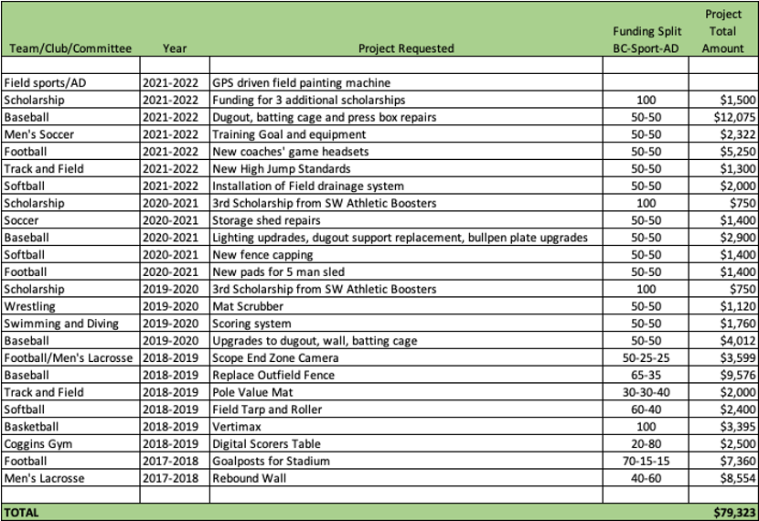
*These items will be used by multiple sports.

NOTE: Delete pages 1-3 when submitting your project request.

SW Athletic Booster Club
Capital Fund Project Request
2022-2023
Date:
Club requesting Funds:
Contact Person:
Phone:
Email:
Please be specific, include written bids for work, dimensions for work, photos, etc.

Title of Project:
Description of need: [Add a summary description (2-3 sentences) of what is being purchased, including the item’s main uses, the reason it is needed, and the benefit]
Annual Return (Money it will earn or save, value provided to the program): [State the earnings or savings you are expecting this purchase to provide. If there are no direct earnings/savings, state whether there is a related cost savings (for example, injury prevention which will help families avoid expenses related to medical care like physical therapy)
Team participates significantly in Primary Boosters fundraisers and activities (Prior 2 yrs) [Describe how your team supports the primary booster club. For example, sell reverse raffle tickets, legacy bricks, provide silent auction items, etc., over the prior 2 years. Also, do any of your current or past board members serve in a main booster position?]
How will the project build the SW Brand? [Provide a summary of how this purchase will help build our athletic program or sport. Will it be visible to the public? Can it be branded with the SW logo?]
Improves Coach or Player Excellence? [List the ways this purchase helps the athletes and/or the Coach]
Cost Estimate (attach bids/quotes): [Provide your recommended vendor/price here, and attach the physical bids/quotes you received from all vendors to this document.]
Request Justification: [State the justification, or reason why this purchase is critical for the team, and list any additional information that will be helpful to the committee in making the decision. For example: Are multiple teams sharing the item? Are teams sharing the cost of the purchase? When must the purchase be completed? What is the funding requested from the Capital Committee?]
_______________________________Do not write below this line_______________________________
Received date : Reviewed date:
Amount requested: Amount provided:
Notes/Comments:

