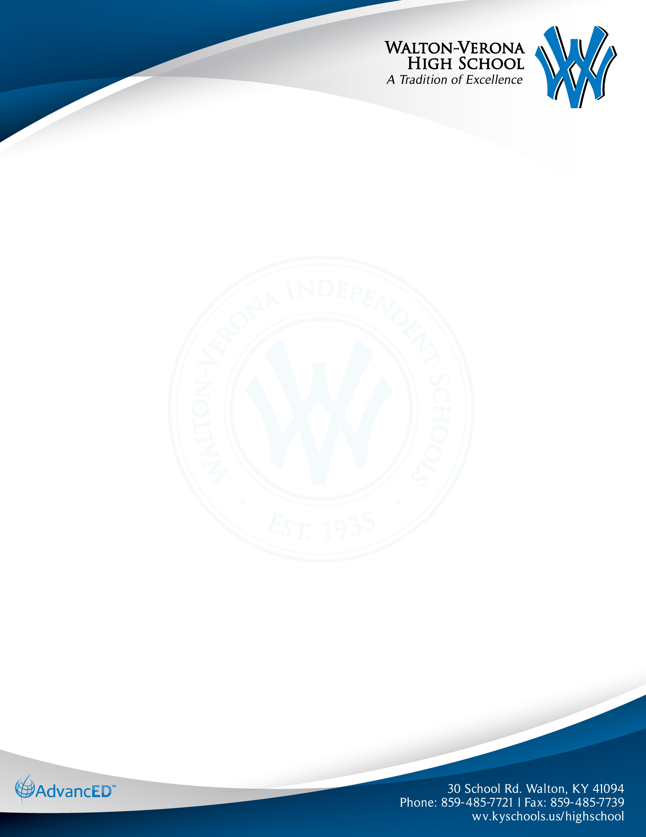

WVHS College Signing Information

Walton-Verona will have three signing days during the school year that will take place during the school day. These will take place at 2:00 in the High School Commons or Multi-Purpose Room (based on the number of signings).

The 2023-24 dates are:

* November 8, 2023
* December 13, 2023
* May 1, 2024

It is the student’s responsibility to inform the Athletic Director of their intent on signing.

Student athletes need to make sure to have this meeting with the athletic director at least a week before the signing dates listed above.

Athletes should give the Athletic Director the financial statement from their college they plan to sign with.

Any student athlete who does not use one of the three dates listed above can still have a signing date after school at 3:00 on a date approved by the Athletic Director and High School Principal.

The school will supply the drinks, plates, napkins, utensils, and a small amount of snacks for the signing. The school will have the site decorated and set up for the event.

Parents can bring decorations to the event (balloons, etc.) along with cookies, brownies, cupcakes, or cake usually in the color or with the school logo on them.

If you have any questions about the signing, please contact Kyle Bennett the Walton-Verona Athletic Director at 859-485-7721 ext. 1231 or [kyle.bennett@wv.kyschools.us](mailto:kyle.bennett@wv.kyschools.us).