September 12, 2022
6:00 pm
CCHS Cafeteria

Attendance: Cindy McKenize, Kim Braitwaite, Wendy Lucier, Jenny Oliver, Darrell Oliver, Ann Bishop, Chuck Bishop, Karen Sowers, Debbie Hardesty, Angela Broy, Kathy Paskal, Sheri Mayo, Andy MacDonald, Cassie DeGeorge, Kelly Summers, Tom ODonnell, John Spencer, Loretta Stem, Kim Lynch, Kim Arthur (Ziercher), Randy Trenary, Jennifer Poston, Sherry May

- Call to Order - meeting was called to order at 6:02 p.m.
- Secretary’s minutes
Motion to accept made by: Loretta Stem
Seconded by: Darrell Oliver
Motion passed, Secretary minutes accepted
Amended to have a certified accountant go over the finances

- Treasurer’s report:
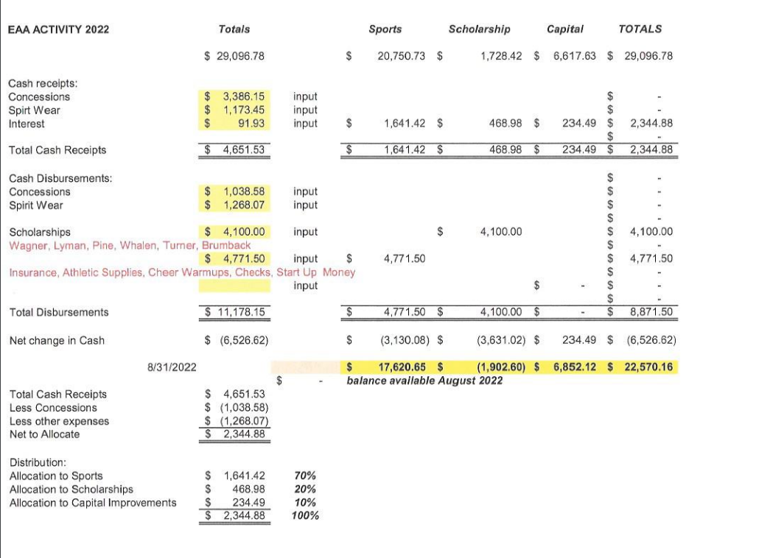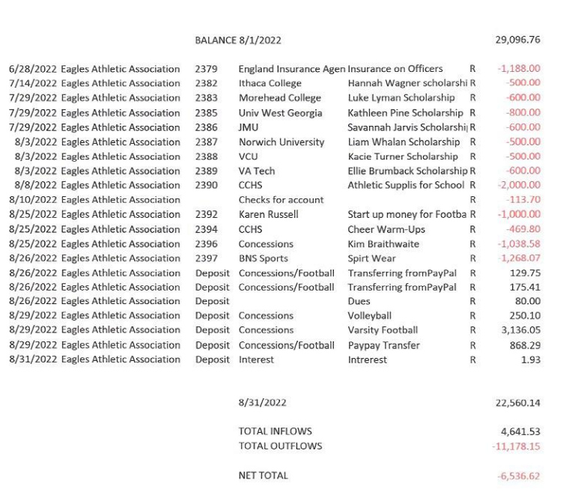
Motion to accept made by: Loretta Stem
Seconded by: Randy Trenary
Motion passed, treasurer’s report accepted
Committee Reports:
- Bluegrass: Bluegrass dates are booked, Randy is working on getting the teams that plan to work the 50/50 and concessions. They are still looking for sponsors if you know anyone please let Randy Trenary know. Randy has reached out to choir directors to see if a student would like to sing the national anthem at each show.
  - November 5 - Waiting to hear back from a team
  - Dec 3 - Cheer
  - Feb 4 - Volleyball
  - March 4th - Track and Field

- Scholarship: Nothing to report. We are in the resting phase.

- Concessions: Having teams signed to the concession was a huge help. Mr. Miller will set up his funnel cake stand at the next home Varsity Football game on 9/23/22. The funnel cakes will be $6. Mr. Miller gives all of the profit back to EAA. If there is anyone willing to help Mr. MIller on 9/23 please let me know.

- Apparel: Kathy Paskel showed a new bag for us to sell. With her approval at the last meeting to spend $3000 on apparel she placed an order for $2800.
  - Apparel Income for the Varsity game was $1547.00 income for the JV game $685
  - Kathy needs to replenish sweatshirts and youth apparel by September 23rd for youth football night at the varsity football game.
  - Kathy requested another $2120 for sweatshirts, bags and youth size shirts
Motion made to approve $2120 by Randy Trenary
Second: Kim Braithwaite
Motion Approved

Old Business:
- Need another member of the association to review financial records and report at the September meeting. Article V of the bylaws addresses the budget.
  - Chuck Bishop, Melissa Sipe and Beth Wolford to review the financial records
  - These minutes were amended to have a professional accountant review the finances
- Collect $5 dues
- Cash Party - Do we want to set a date - We need a committee that's willing to help out. We need to start working on donations. Email companies
  - Set a date: A date will be set by the next meeting
- Football Concessions Sign Up Sheets
  - Football Varsity Gate - volunteersignup.org/LF7DF
  - Football Varsity Concession - volunteersignup.org/WLBFY
  - Football JV Gate - volunteersignup.org/M9QBC
  - Football JV Concession - volunteersignup.org/KR3ET
- Card Reader - This is being looked into
  - Concession Stand
  - Gate
New Business:
- A member has asked if there is a way to add a virtual meeting -
  - We would need someone to set up the virtual meeting, you must be present to vote on anything but if you would like to listen in this could be a good alternative.
- Need to schedule date after May 1, 2023 for VHSL Physical schedule - Dr. Aiello
  - Deb called Dr. Aiello, she is waiting to hear back from her, but we DO plan to start the VHSL physicals again.
- Cindy McKenzie to speak about Moose Apple Christmas Tree Farm concession help.
  - Moose Apple Christmas Tree Farm sets up concessions when they open for the season. They have offered EAA to come out and set up and work the concession stand. EAA will be given all of the proceeds earned each day. Cindy will get further information on the hours.
  - Would anyone like to take charge of getting volunteers set up for this?

- Thank You notes:
  - Lindsay Gregio, Kathleen Pine, Clarke Cheer team
- Girls basketball: Coach Downing from CCHS Girls Basketball is requesting $3100 from EAA to purchase warm up shirts and new travel bags. They have not requested money since 2015 their quotes were $1399 for backpacks and $1696 for shooting shirts.
  - Motion made to approve $3100 given to Girls basketball - Randy Trenary
  - Seconded - Karen Sowers
  - Motion Passed
Nissan Pavilion is in need of volunteers to help at concerts. Anyone that volunteers Nissan will pay the organization of their choice (EAA). Kathy Paskal is going to give Nissan a call to see if we can get involved in this.
Recording Secretary: Jamie Sansom
Adjournment: Motion to adjourn made by Randy Trenary and seconded by Loretta Stem and adjourned at 6:27 p.m.
Next meeting: 10/10/22
Future meetings: 11/14/22, 12/12/22, 1/9/23, 2/13/23, 3/13/23, 4/10/23, 5/8/23

