September 11, 2023
6:00 pm
CCHS Cafeteria

Attendance: Deb Hardesty, Jamie Sansom, Cassie DeGeorge Lisette Pippy, Kim Braithwaite, Karen Russell, Tiffany Roper, Tim Wagner, Cheryl Marchisano, Carol Marshall, Ricky Barton, Kim Lynch, Loretta Stem, Justine Jarvis, Krissy Chinn

Call to Order - meeting was called to order at 6:00 p.m.
Secretary’s minutes
Motion to accept made by: Loretta Stem
Seconded by: Carol Marshall
Motion passed, Secretary minutes accepted

Treasurer’s report:
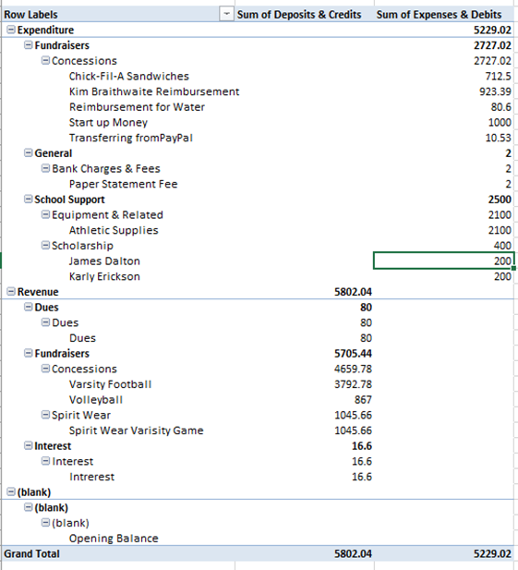
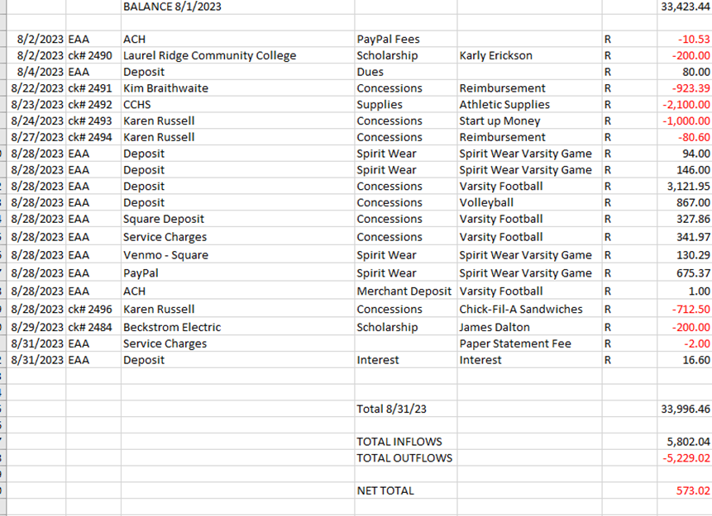
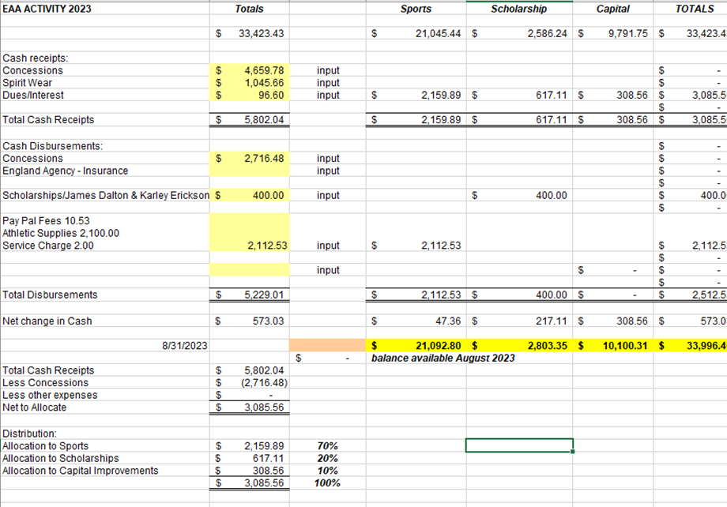

Motion to accept made by: Justine Jarvis
Seconded by: Loretta Stem
Motion passed, treasurer’s report accepted
Committee Reports:
- Scholarship: Nothing to report
- Concessions: Concessions are going well, the Ipad is super helpful. We are charging a convenience fee for each transaction and have posted the fee at the concession stand. Funnel cakes will be made at the home football game this Friday. We are looking for volunteers to help with funnel cakes
- Apparel: Need to replenish

Old Business:
- Ipad - An Ipad was generously donated by Cheryl Marchisano and a chrombook was generously donated by Carol Marshall donated
- New Prices for Concessions - Does everyone seem ok with the changes?
- Moose Apple Christmas Tree Farm - Cindy McKenzie

New Business:
- Need to schedule date after May 1, 2023 for VHSL Physical schedule - Dr. Aiello - Deb will contact Dr. Aiello
- Requesting $2700 to order new apparel, motion made by Carol Marshall second by Ricky Barton; Request approved.
- Fundraiser idea, one large basket. All teams that provide a gift card sell them for $10 start on October 13th and end it on December 11th after our EAA meeting. Motion to approve fundraiser: Ricky Barton Seconded by Carol Marshall
- Coach Smith is looking to purchase a pitching machine at on Deck Sports $2599 which includes shipping and tax. Motion was made to approve $2600 to baseball by Kim Braithwaite seconded by Ricky Barton.
- We would like to donate $100 from Marios and $100 from Camino to our tax lady. Motion made by Carol Marshall seconded by Justine Jarvis.
Recording Secretary: Jamie Sansom
Adjournment: Motion to adjourn made by Ricky Barton and seconded by Loretta Stem and adjourned at 6:17 p.m.
Next meeting: 10/9/23
Future meetings: 11/13/23, 12/11/23, 1/8/24, 2/12/24, 3/11/224, 4/8/24, 5/13/24

