August 8, 2022
6:00 pm
CCHS Cafeteria

Attendance: Jamie Sansom, Kathy Childs, Kim Braithwaite, Debbie Hardesty, Alison Palmer, Karen Russell, Tara Darlington, Chris Darlington, Krissy Chinn, Jennifer Poston, Stacy Poston, Kim Denison, Darcie Goode, Loretta Stem, Michele Cox, Adrian Taylor, Carissa Ferraro, Stacey Ellis, Patty Erickson, Gabrielle Whalen, Allison MacDonald, John Spencer, Sally Spencer, Joy Dyer, Mike Wagner, Julie Hoggatt, Justine Jarvis, Amy Kenny, Anne and Chuck Bishop, Cassie DeGeorge, Tiffany Roper, Kelly Summers, Angi Broy, Melissa Sipe, Kathy Paskal, Kristi Booker, Loretta Stem, Ashley Cease, Heather Cease, Elaine Crawford, Maria Zimmerman

If you were left off this list please email me letting me know. There were a lot of attendees last night, which is GREAT!

Call to Order - meeting was called to order at 7:17 p.m.
Secretary’s minutes:
Motion to accept made by: Kristi Booker
Seconded by: Allison Plummer
Motion passed, minutes accepted
Treasurer’s report: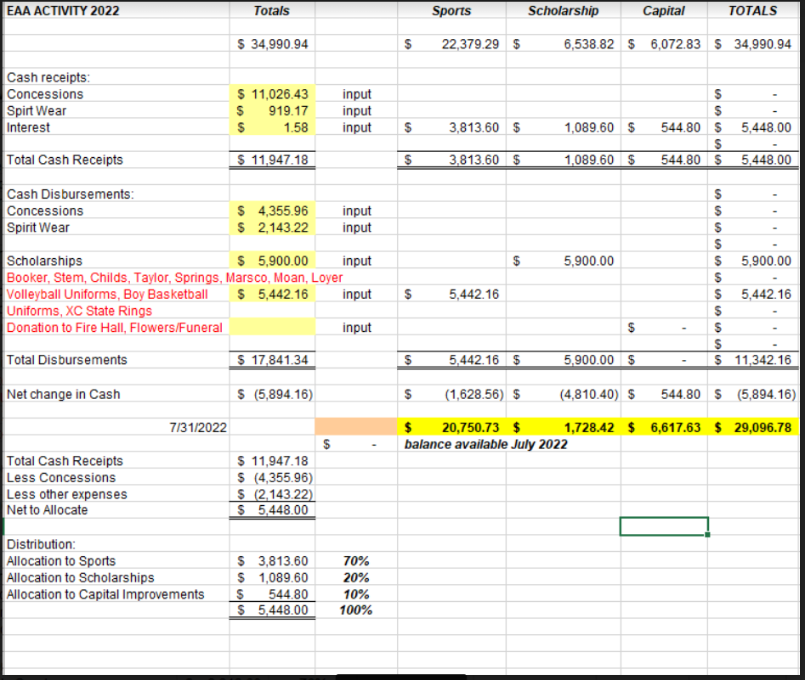
Motion to accept made by: Melissa Sipe
Seconded by: Michele Cox
Motion passed, treasurer’s report accepted
Committee Reports:
- Bluegrass - *The 2022-2023 Eagle Bluegrass Series is ready to roll! We have another great lineup of both Regional and National talent. Second chance season tickets are on sale starting tomorrow morning at eaglebluegrass.com . We are trying to boost the season ticket sales before we open up the individual show ticket sales. Please help spread the word. I have flyers if anyone wants them to hand out or sit on the counter at their business.

- Scholarship - Thank you notes read

- Concessions - We are working on getting the sign up genie out each parent from the Fall sports will have a Concession Mom
  - Football Varsity Gate - volunteersignup.org/LF7DF
  - Football Varsity Concession - volunteersignup.org/WLBFY
  - Football JV Gate - volunteersignup.org/M9QBC
  - Football JV Concession - volunteersignup.org/KR3ET

- Apparel - Inventory is very low. Kathy Pakal is requested bucket hats, Stadium Seats Garden Flags, Cooling Shirts, Coin Purses and Cotton Short Sleeve Shirts- requesting $3000 to purchase new apparel
  - Motion to approve Angi Broy
  - Second - Allie Plummer
  - Motion approved

Old Business: N/A
New Business:
- Need 3 members of the association to review financial records and report at the September meeting. Article V of the bylaws addresses budget.
  - Chuck Bishop & Allison MacDonald to review the financial records
- Collect Dues - $5 each year per family - Karen will take
- Need to schedule date after May 1, 2023 for VHSL Physical schedule - Dr. Aiello
- Thank you notes from scholarship recipients.
  - Thank you notes read from Dain Booker, Bella Stem, Caleb Childs, Savannah Jarvis, TJ Lowery, Luke Lyman
- Football Concession and Gate are being asked to be covered by other teams (Golf, Wrestling, Tennis, Swimming) Suggestion:
  - Krissy Chinn will email out the sign up genie and notify the Golf, Wrestling, Swimming, Tennis and Cross Country Coaches know they will be given a date for their parents to cover
- Cash Party - We will host another cash party around February 2023 - Not not set as of today
- Lindsay (trainer) requesting First Aid equipment requesting $2000.00
  - Motion Made - Loretta Stem
  - Second - Kristi Booker
  - Motion Approved

- Brooke Price - Cheer Team - requesting additional warmups due to the lack of sizes from her last request. Requesting $470.00
  - Motion made: Kathy Childs
  - Second; Kathy Paskel
  - Motion approved
Recording Secretary: Jamie Sansom
Adjournment: Motion to adjourn made by Melissa Sipe and seconded by Allie Plummer and adjourned at 7:53 PM p.m.
Next meeting: 9/12/22
Future meetings: 10/10/22, 11/14/22, 12/12/22, 1/9/23, 2/13/23, 3/13/23, 4/10/23, 5/8/23

