April 8, 2024
6:00 pm
CCHS Cafeteria

Attendance: Jamie Sansom, Cassie DeGeorge, Deb Hardesty, Steph Mercer, Kim Braithwaite, Tanya Barton

- Call to Order - meeting was called to order at 6:00 p.m.
- Secretary’s minutes
Motion to accept made by: Kim Braithwaite
Seconded by: Steph Mercer
Motion passed, minutes accepted
- Treasurer’s report
Motion to accept made by: Correction of new grill, it went to baseball not softball motion made by Cassie DeGeorge
Seconded by: Steph Mercer
Motion passed, minutes accepted 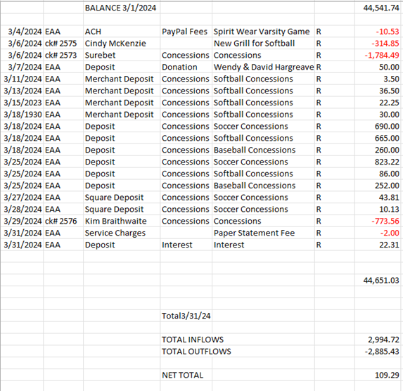
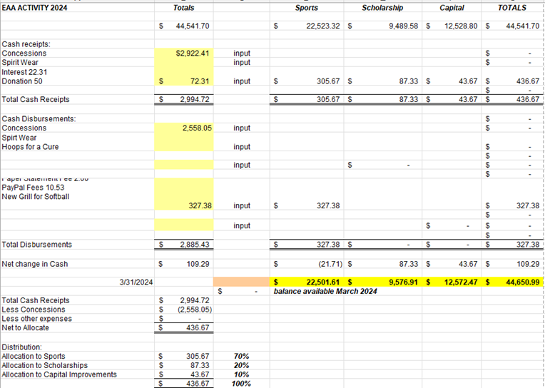

Committee Reports:
- Scholarship - Scholarships were due today, we are waiting on the paperwork from Ms. Broy
- Concessions -
  - Stadium concessions grill is not working. Joey is looking to see if he can figure out what is going on. Motion made by Cassie DeGeorge to purchase a new grill at the stadium if needed max of $500. Seconded by Steph Mercer
  - If there are adults at the concession stand we would like for them to manage the money rather than the children.
  - Cassie will make a sign to stop cooking at some point and to notate that if you work the concession stand that anything consumed needs to be paid for.
- Apparel -
  - Berryville Treasure wants to set up at little league nights for sports
- Fundraising -
  - Emmart’s Scholarship was endowed - We are hoping to come up with another fundraiser to continue to support Coach Emmart

Old Business:
Present slate of officers to be voted on in the May meeting. If anyone wants to apply for a position please let us know.
- Kim Braithwate presented a slate of officers
    - President - Debbie Hardesty
    - Vice President - Jamie Sansom
    - Treasurer - Karen Russell
    - Secretary - Jo Paige Anderson

- All of the 501c3 paperwork is finished and has been turned into the lawyer, we are waiting to hear back from him. Vote on the conflict of Interest Policy for the new EIN#
  - Motion made by: Tanya Barton
  - Seconded by: Cassie DeGeorge
- Hot spots from Consumer Cellular looking to purchase 1 hot spots up to $60 and 1 square up to $60
  - Motion made by Tanya Barton
  - Seconded by: Cassie DeGeorge
- TV in Concession stand with NFHS
  - Need to speak with Novick to see if this will work and what needs to be done
New Business:
- The cheer team would like to purchase new uniforms. Tamara has submitted quotes for approval. She is requesting $6200.60 for 20 reversal cheer uniforms.
  - Motion Made by: Jamie Sansom
  - Seconded by: Steph Mercer

Recording Secretary: Jamie Sansom
Adjournment: Motion to adjourn made by Jamie Sansom and seconded by Karen Russell and adjourned at 6:40 p.m.
Next meeting: 5/13/24
Future meetings: 8/12/24

