March 13, 2023
6:00 pm
CCHS Cafeteria

Attendance: Angela Broy, Jamie Sansom, Randy Trenary, Justine Jarvis, Maria Zimmerman, Sally Spencer, John Spencer

Call to Order - meeting was called to order by Randy Trenary at 6:03 p.m.
Secretary’s January minutes
Motion to accept made by: Randy Trenary
Seconded by: Justine Jarvis
Motion passed, minutes accepted
Treasurer’s report
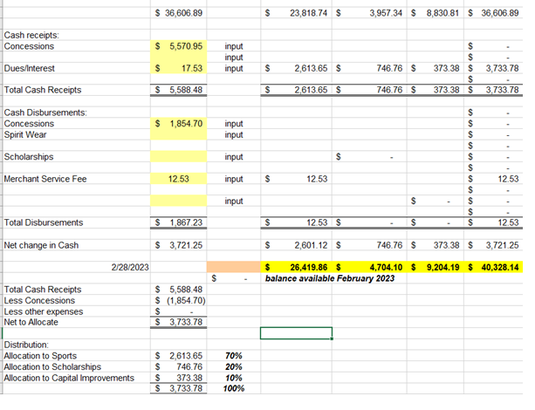
We purchased pop up goals for boys soccer – 1,350.00
Motion to accept made by: Randy Trenary
Seconded by: Justine Jarvis
Motion passed, treasurer’s report accepted

Committee Reports:
- Bluegrass - We just finished our last show, we will have to change up what we are currently doing, the amount of season ticket holders is decreasing. National Acts are costing us $3500 and up to $6000. We received $9500.00 from sponsors our total expenses were $26,889.23 our total income was $30,453.38 total profit $3,564.15. We are looking to find a band to play at the fairgrounds this Spring. Randy Trenary is going to look for 4-5 bands to see if he can come up with a list of bands to participate.
- Scholarship - Nothing to report
- Concessions -
  - Karen called the contact for girls soccer concession – she said she was going back today to clean the floors. I gave her all of the information for concessions.
  - Please note the if the volunteers in charge of concessions need change please text Karen and she will have it there by next game
  - Karen purchased 6 new cans of propane yesterday – 1 at baseball, 1 at Softball, 4 at football concessions
  - Karent took the money to each field yesterday
  - Karen replenished 4 cases of water to Baseball, 4 cases of water to softball, and 14 cases at football concessions
  - Karen is writing herself a check for $231.41 to pay myself back for water, propane gas and batteries (see attached as proof of purchase)
  - Karen put fresh oil in the frier and it’s ready to go
- Apparel -
  - Kathy P will speak about the shirts for the cancer survivors. She asked if we would pay the vendor again she would use the swipe thing to collect the money for the shirts
  - There has been no money deposited into the account. Once the money is deposited I will pay vender – Karen needs the information to pay

Old Business:
- School Physicals are set for May 13th 9-12 boys first and then girls. A donation of $10 is charge goes to Lindsey for supplies.

New Business:
- Cash donation from Akre Capital Management $2000 and the Booker Family $2000. This money is to go to scholarships or the cash party which funds the scholarships.

- Thank you to Cassie DeGeorge - She has been working with all of the coaches on getting baskets and came up with the idea of an online basket auction due to us not being able to have a cash party. She has researched online bidding sites and already received some baskets from coaches. Thank you coaches as well for responding and getting her baskets. Jamie is working to get the baskets online, we are hoping to have them online by the end of the week for people to purchase tickets.

- The Spring Market April 30th is in full force, we have several vendors lined up to come, we will still need some volunteers for that day to help out. $5 to get in and vendors will pay $30 for a table/spot. We also plan to have 50/50 drawings throughout the day.

Recording Secretary: Jamie Sansom
Adjournment: Motion to adjourn made by Randy Trenary and seconded by Justine Jarvis and adjourned at 6:33 p.m.
Next meeting: 4/10/23
Future meetings: 5/8/23

