March 11, 2024
6:00 pm
CCHS Cafeteria

Attendance: Not enough to have a meeting…

Call to Order - meeting was called to order by at p.m.
Secretary’s January minutes
Motion to accept made by:
Seconded by:
Motion passed, minutes accepted
Treasurer’s report
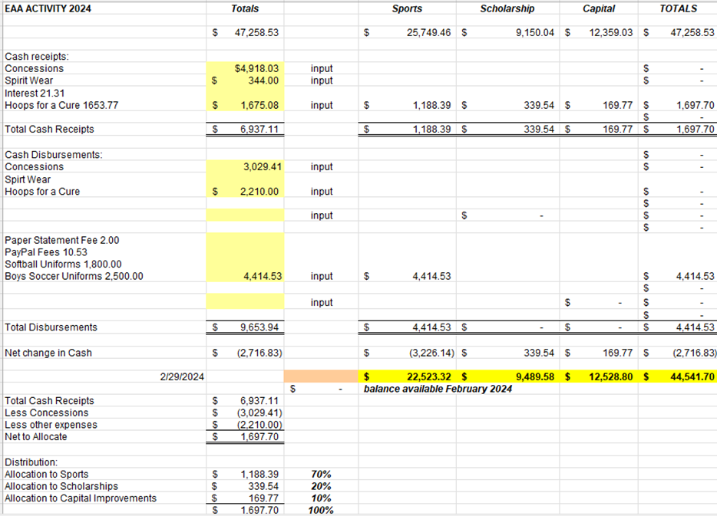
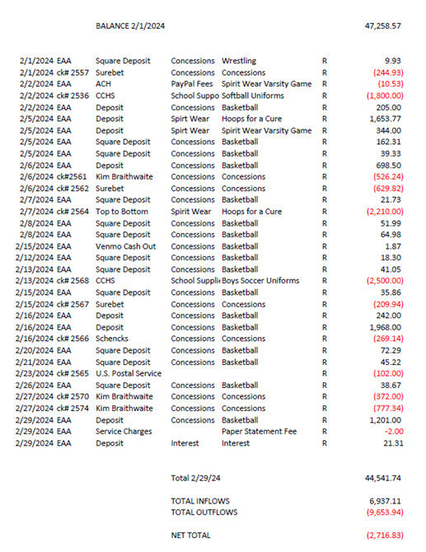
Motion to accept made by:
Seconded by:
Motion passed, treasurer’s report accepted

Committee Reports:
- Scholarship -
- Concessions -
- Apparel -
- Fundraising-

Old Business:
- All of the 501c3 paperwork is finished and has been turned into the lawyer, we are waiting to hear back from him.

New Business:
- Unfortunately Cassie DeGeorge will be stepping down from the VP position. We are looking to replace the secretary position as Jamie Sansom will move to the VP position.
- Hot spots from Consumer Cellular - Approval to purchase Hotspot that you only pay for what you want to use.

Recording Secretary: Jamie Sansom
Adjournment: Motion to adjourn made by and seconded by and adjourned at p.m.
Next meeting: 4/08/24
Future meetings: 5/13/24

