February 12, 2024
6:00 pm
CCHS Cafeteria

Attendance: Jamie Sansom, Kim Braithwaite, Karen Russell, Kim Arthur, Patrick Casey, Deb Hardesty, Sally Spencer, Margaret Kennedy

- Call to Order - meeting was called to order at 5:57 p.m.
- Secretary’s January minutes
Motion to accept made by: Karen Russell
Seconded by: Kim Arthur
Motion passed, minutes accepted
- Treasurer’s report: To be posted before the meeting
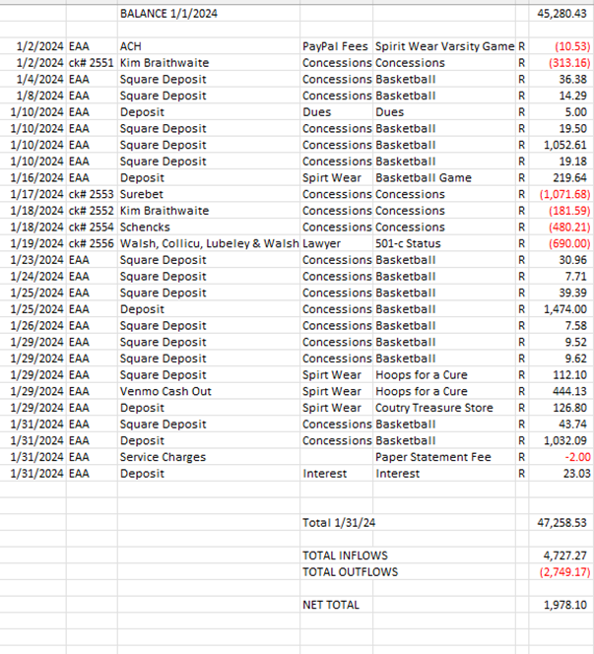
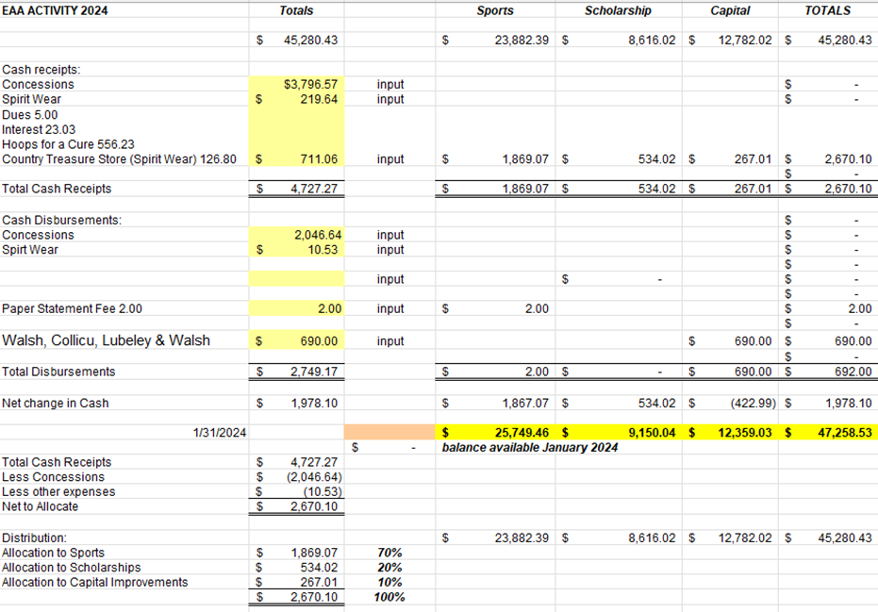
Motion to accept made by: Sally Spencer
Seconded by: Kim Arthur
Motion passed, treasurer’s report accepted
Committee Reports:
- Scholarship - Senior meeting was last week all kids received their packets.

- Concessions - Concessions have been going extremely well.
  - Softball is asking for an updated menu, Margaret Kennedy is putting hardware on all of the cabinets.
  - Basketball will possibly be played on Wednesday. We will need help with concessions that day.

- Apparel - Nothing to report

- Fundraising - Nothing to report

Old Business:
- Any update on the 501c3 - Still pending, we have not heard back from the accountant.
  - Karen made a motion to pay $500 to finish the process
  - Seconded by Margaret Kennedy

- Softball received $1800 to purchase new uniforms

- Thank you note received from Wrestling

New Business:
- TV for Concession Stand with NFHS

- Boys Soccer would like new uniforms
  - Boys Soccer is asking for $2500 for new uniforms and training equipment. He provided three quote
    - Motion made to give soccer $2500 by KIm Arthur
    - Seconded by KIm Braithwaite

Recording Secretary: Jamie Sansom
Adjournment: Motion to adjourn made by Kim Arthur and seconded by Karen Russell and adjourned at 6:14 p.m.
Next meeting: 3/11/24
Future meetings: 4/8/24, 5/13/24

