December 12, 2022
6:00 pm
CCHS Cafeteria

Attendance: Randy Trenary, Karen Russell, Debbie Hardesty, Kathy Paskel, Sheri Mayo, Krissy Chinn, Loretta Stem, Maryam Tabatabai, Charity Danjczek, Kim Ziercher

- Call to Order - meeting was called to order at 6:01 p.m.
- Secretary’s minutes
Motion to accept made by: Randy Trenary
Seconded by: Loretta Stem
Motion passed, minutes accepted
- Treasurer’s report
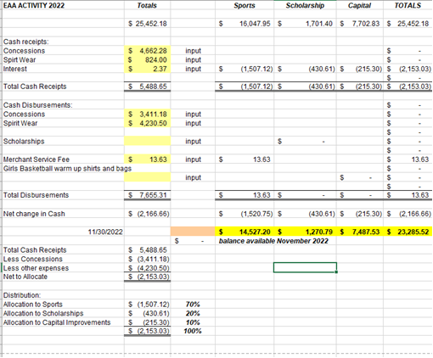
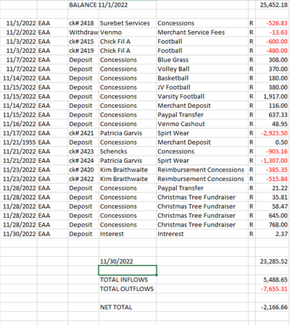

Motion to accept made by: Randy Trenary
Seconded by: Loretta Stem
Motion passed, treasurer’s report accepted
Committee Reports:
- Bluegrass: Halfway through the season, 1st show approximately 115-120 attended. Disappointing with the act as good as they are. Second show was better, a member of the band was from Winchester so that may be the reason. We’re behind in ticket sales and would like to break even. We did receive a $10k in sponsorship to support the season. If we see the ticket sales on Facebook, please share the upcoming shows. Hope to put a banner on the fence along Rt. 7 at the Fairgrounds for advertising the future shows. We did send info to Winchester Star, they did not advertise. Northern Virginia Daily did share, but in the announcement section so could’ve been missed. Sent to Clarke Monthly and they did not share. We need to share on Facebook and ensure people are aware they will be able to purchase at the door if not able to access computer sales.
Old Business:
- Christmas Tree Farm was a success. In 4 days the total was $5,528. $3,031 in cash, $2,287 credit, 207.26 Venmo, 2.88 PayPal. Hope to do again next year. We would like to thank everyone that helped make it a success, a huge thanks to those that were leaders in making it happen. Thanks for donations and everyone's time!

- Scholarship: Nothing to report
- Concessions: Going well, will check with Jessica Vincent about wrestling as she is team mom and she will be in charge of that.
- Apparel: plan to sell and basketball and will move items over this week.
- Dues: Senior parents must pay $5 by January 1st to be considered for a scholarship. This is for any sport.
- Physicals: Date is set, and will be held in May
- Cash Party - Randy spoke with Van at Enders and they have not received their license. Unfortunately they are the only ones that can host the party (no outside groups) and that will be across the board for Enders, Blue Ridge and Boyce locations. Randy will check to see if we can apply for a license on our own and if the party has to be hosted on the site location of that particular group. If so, the school grounds will not work.
New Business:
- New Business: Maryam asked if there was a plan B for the Cash Party. Discussed the success of the FFA calendar type fundraisers. Concerns of profit if not able to do Cash Party. Would like scholarships to be at $10k.
- Meeting to discuss the installation of lights on softball and baseball fields, upgrade to football and parking lot will be at the conclusion of the next EAA meeting. The vendor, in which all VA schools use, will be in attendance.

Recording Secretary: Krissy Chinn

Adjournment: Motion to adjourn made by Randy Trenary and seconded by Loretta Stem and adjourned at 6:24 p.m.
Next meeting: 1/10/22
Future meetings: 2/12/22, 1/9/23, 2/13/23, 3/13/23, 4/10/23, 5/8/23

