December 11, 2023
6:00 pm
CCHS Cafeteria

Attendance: Jamie Sansom, Cassie DeGeorge, Tiffany Roper, Kim Braithwaite, Debbie Hardesty, Karen Russell, Tanya Barton, Michele Neiman, Kim Arthur

- Call to Order - meeting was called to order at 6:01 p.m.
- Secretary’s minutes
Motion to accept made by: Karen Russell
Seconded by: Tiffany Roper
Motion passed, minutes accepted
- Treasurer’s report
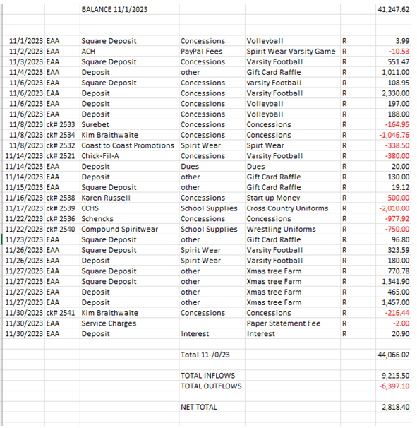
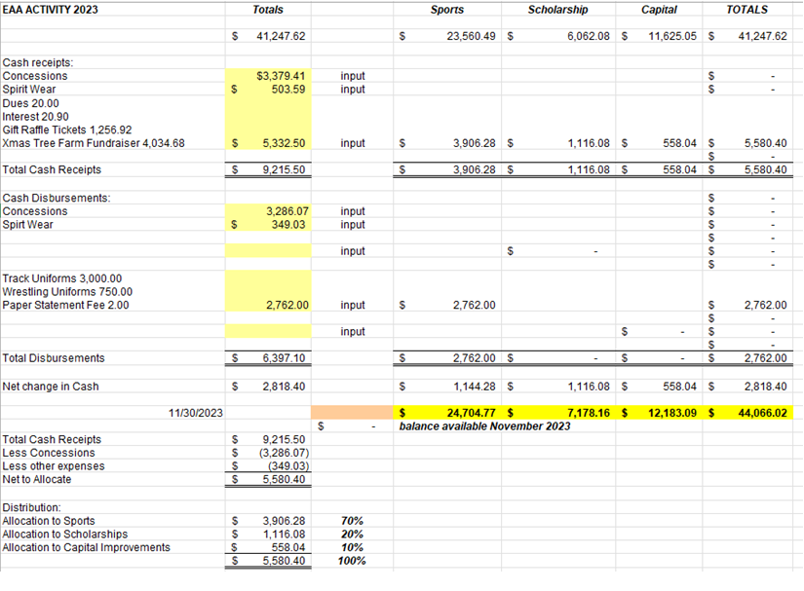

Motion to accept made by: Jamie Sansom
Seconded by: Cassie DeGeorge
Motion passed, treasurer’s report accepted
Committee Reports:
- Scholarship: To early to discuss
- Concessions: Everything is going well
- Apparel: Nothing to report
- Fundraising:
  - Moose Apple Christmas Tree Farm - We made $5,878.35. Thank you to everyone that donated and helped out at the farm.
  - Set up Committees
  - Committee to help with ideas to raise funds for the Brent Emmart Scholarship. (Jamie)
  - Gift Card Raffle made: Total made for the raffle $2570.0
    - CONGRATULATIONS TO KIM LYNCH for winning the raffle this evening!
Old Business:
- Physical Date: Dr. Chris has been contacted, it will be in May. Deb is working on getting dates together to see what was
- Coach Webster was approved for $2010 this was approved
- Coach Vansice asked for $750 for singlets this was approved

New Business:
- Gift Card Raffle Drawing
- Coach Hawkins is looking for $3500 for warmups they will purchase tops and bottoms for 40 girls which includes JV and Varsity
  - Motion Made to give girls soccer $3500 - Jamie Sansom
  - Seconded by: Karen Russell
  - Motion accepted

Recording Secretary: Jamie Sansom
Adjournment: Motion to adjourn made by Karen Russell and seconded by Tonya Barton and adjourned at 6:17 p.m.
Next meeting: 1/8/24
Future meetings: 2/12/24, 3/11/224, 4/8/24, 5/13/24

