November 14, 2022
6:00 pm
CCHS Cafeteria

Attendance: Jamie Sansom, Deb Hardesty, Steve Fox, Kim Author, Jeff McLearen, Angie Broy, Melissa Sipe, Tiffany Roper, Krissy Chinn, Sherri Mayo, Karen Russell, Kathy Paskal, Lor O'Donnell, Andy McDonald, Justine Jarvis, Maria Zimmerman, John Spencer, Sally Spencer, Kim Braithwaite, Kim Lynch

- Call to Order - meeting was called to order at 6:03 p.m.
- Secretary’s minutes
Motion to accept made by: Karen Russell
Seconded by: Lori O'dOnnell
Motion passed, minutes accepted

- Treasurer’s report
Motion to accept made by: Cindy McKenzie
Seconded by: Melissa Sipe
Motion passed, treasurer’s report accepted
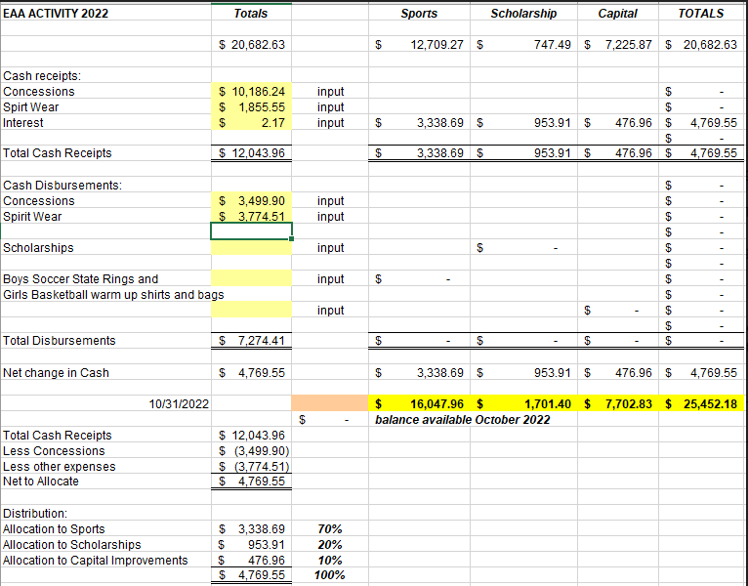
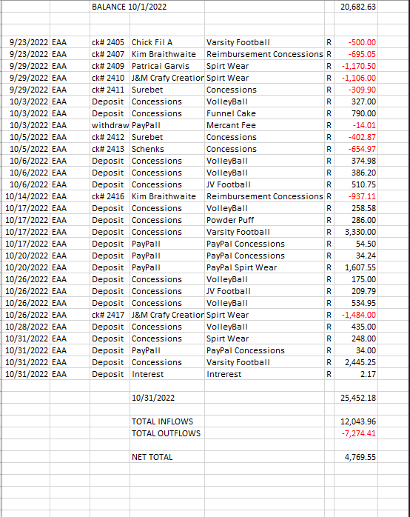

Committee Reports:
- Bluegrass: This is going well, we need to get the word out more. Some people were upset that they didn’t know about the concerts. Need to update the website to state where the concerts are being held.
- Scholarship: Nothing to report at this time.
- Concessions: Thank you to Tiffany Roper, Micheila Vorous and Angie Broy for working the concession stand during the Powder Puff game. Tiffany said it was pretty busy, we should open again next year but also sell hot dogs.n
  - Wrestling - Vincent
  - Boys Basketball - Sansom
  - Girls Basketball - Bishop
- Apparel: Nothing to report, the new items sold well during homecoming.

Old Business:
- Moose Apple Christmas Tree Farm: Cindy McKenzie will give an update. We need a lot more volunteers for this event. https://volunteersignup.org/Q9CFF
- VHSL Physical schedule Dr. Aiello
  - Deb spoke with Dr. Aiello, she does plan to start this up again. She is going to set a date and let Deb know. She is set for two different weekends in May. May 6th or 13th. There is a $10 donation that goes to Lindsay the athletic trainer for her supplies.
- Cash Party: Date was set, but we have to change it again. Discussion for dates tonight.
    - Need to set up a committee for this
    - Need to get the gaming paperwork figured out before we can set a date
  - Baskets - Cassie DeGeorge
  - Hanging fliers
  - Requesting Donations
  - Food - Collecting food and deciding on what to serve - Get food donations
  - Drinks
  - Bar
  - Caller - Fly Lambert, Cheri Lambert
  - Tip schedule
  - Set up
  - Clean up
  - Desserts
  - Ticket Sellers
  - Card Puller
  - Silent Auction Helper
New Business:
- Lights on the baseball & softball fields - Steve Fox is trying to find a committee to help get lights on the baseball and softball fields. Anyone with ideas on how to help come up with money please reach out to Steve Fax at tanddbeagles@gmail.com. He reached out to Musko about pricing and is trying to get the ball rolling. Musko came up with a package that would consist of adding lights to the baseball and softball field as well as upgrading the football field lights. They would also adda 25 year warranty. The rough estimate to do this project is 700K.
- Congratulations to the Girls Cross Country Team and Boys Football Team on such a great season.
Recording Secretary: Jamie Sansom
Adjournment: Motion to adjourn made by Cindy McKenzie and seconded by Sherri Mayo and adjourned at 6:37 p.m.
Next meeting: 12/12/22
Future meetings: 1/10/22, 2/12/22, 1/9/23, 2/13/23, 3/13/23, 4/10/23, 5/8/23

