November 13, 2023
6:00 pm
CCHS Cafeteria

Attendance: Debbie Hardesty, Jamie Sansom, Tiffany Roper, Coach Webster, Ricky Barton, Cindy McKenzie, Cassie DeGeorge, Justine Jarvis, Carol Marshall, Sally Spencer, Charity Dancheck, Ray Hawkins

- Call to Order - meeting was called to order at 6:01 p.m.
- Secretary’s minutes
Motion to accept made by: Cindy McKenzie
Seconded by: Justine Jarvis
Motion passed, minutes accepted

- Treasurer’s report
Motion to accept made by: Justine Jarvis
Seconded by: Cassie DeGeorge
Motion passed, treasurer’s report accepted
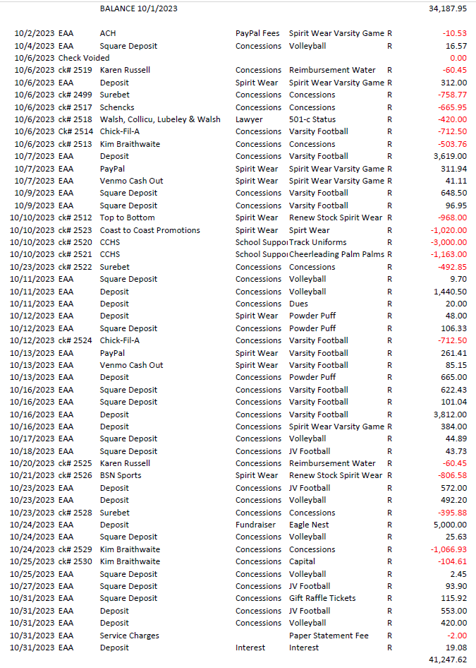
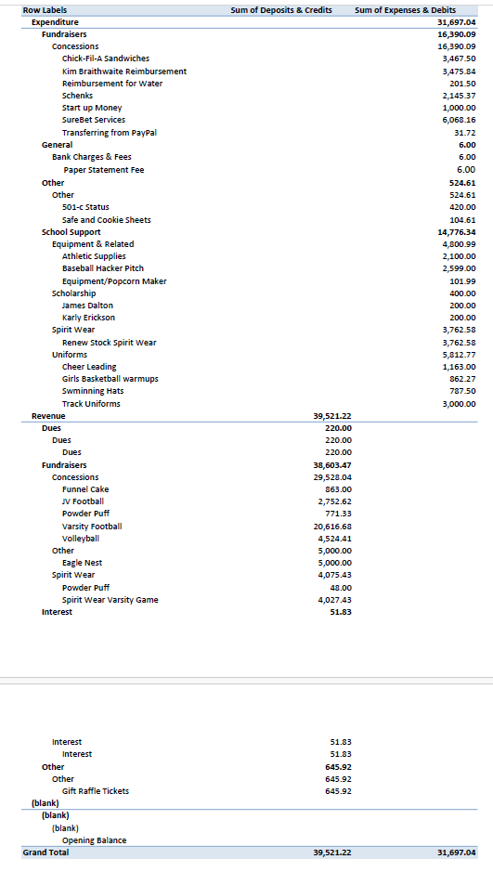
Committee Reports:
- Scholarship: To early to discuss
- Apparel: Nothing to report

- Concessions:
  - Wrestling Concession - Jessica Vincent
  - Boys Basketball - Need a team mom for this
  - Girls Basketball - Ann Bishop
  - Ricky Barton will get the drinks from the outside concession stand and bring them to the inside concession.

Old Business:

- Moose Apple Christmas Farm we still need volunteers and donations for this
  - November 24th, 25th and 26th, December 2nd, 3rd, 9th, and 10th.
  - One adult must be present
- Gift Card Basket - We have not sold nearly enough, we need to start pushing this fundraiser

New Business:
- Congratulations to the Cross Country and Football team on their success this season.
- Coach Webster is requesting to purchase uniforms for the Cross Country Team in the amount of $2010
  - Motion to accept made by: Cindy McKenzie
  - Seconded by: Karen Russell
  - Motion passed, minutes accepted

Recording Secretary: Jamie Sansom
Adjournment: Motion to adjourn made by Ricky Barton and seconded by Justine Jarvis and adjourned at 6:26 p.m.
Next meeting: 12/11/23
Future meetings: 1/8/24, 2/12/24, 3/11/224, 4/8/24, 5/13/24

