October 10, 2022
6:00 pm
CCHS Cafeteria

Attendance: Jamie Sansom, Kim Braithwaite, Deb Hardesty, Angela Broy, Cassie DeGeorge, Kathy Childs, Chuck Bishop, Ann Biship, Cindy McKenzie, Maria Zimmerman, Loretta Stem, Tiffany Roper, Julie Dalton, Christina Price, Wendy Lucier, Lacy Morise, Maryam Tabatabai, Randy Trenary, Kim Lynch, Kim Arthur

- Call to Order - meeting was called to order at 6:03 p.m.
- Secretary’s minutes
Motion to accept made by: Randy Trenary
Seconded by: Loretta Stem
Motion passed, minutes accepted
- Treasurer’s report
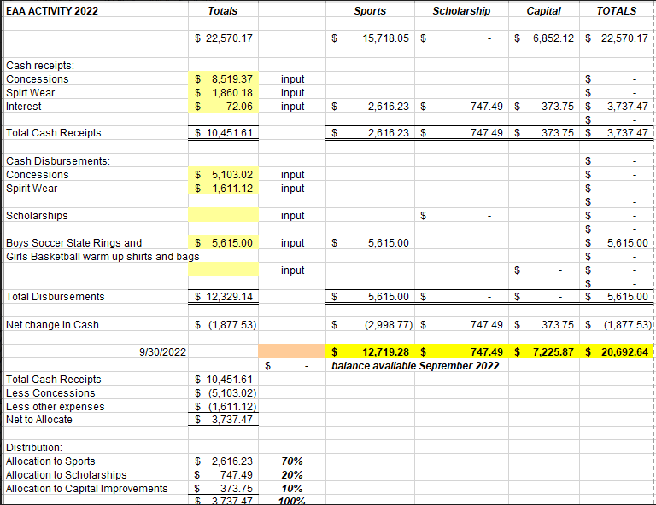
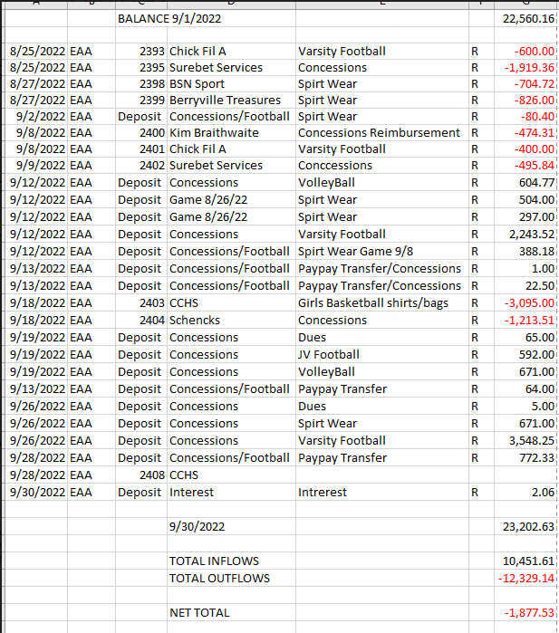
Motion to accept made by: Randy Trenary
Seconded by: Kathy Childs
Motion passed, treasurer’s report accepted
Committee Reports:
- Bluegrass- The first show is a couple of weeks away. Each show has a High School student singing the National Anthem. Randy will need help on the 5th before the show, until he shows up. Tickets are on sale now, put the word out.
- Scholarship - Nothing to report
- Concessions - Everything is going well. We are looking for a few volunteers to work a limited menu concession stand for the Powder Puff game this Thursday. Please let us know if you are interested in working.
- Apparel -
  - They will be open from 3-6 at the parade if anyone want to purchase apparel

Old Business:
- VHSL Physical schedule Dr. Aiello
  - Deb spoke with Dr. Aiello, she does plan to start this up again. She is going to set a date and let Deb know.
- Moose Apple Christmas Farm (Cindy McKenzie)
  - Last weekend in November and first weekend in December 9-5
  - We need to get a volunteer list together of people willing to help. A volunteer sign up sheet will be going out within the next week for volunteers to sign up to work and donate items.

- Nissan Pavilion Volunteer work (Kathy Paskal)
  - Update on Jiffy Lube live, still waiting to hear back from Jiffy Lube, the season doesn't open until July
- Cash Party set for January 14th 2023
  - Need to set up a committee for this
    - Baskets - Cassie DeGeorge
    - Hanging fliers
    - Requesting Donations
    - Food - Collecting food and deciding on what to serve - Get food donations
    - Drinks
    - Bar
    - Caller - Fly Lambert, Cheri Lambert
    - Tip schedule
    - Set up
    - Clean up
    - Desserts
    - Ticket Sellers
    - Card Puller
    - Silent Auction Helper
  - Waiting for paperwork to be filled out for the gaming commission. Will talk with Enders and Blue Ridge to see what we need to do.
New Business:
- No new business

Recording Secretary: Jamie Sansom
Adjournment: Motion to adjourn made by Randy Trenary and seconded by Cindy McKenzie and adjourned at 6:19 p.m.
Next meeting: 11/14/22
Future meetings: 12/12/22, 1/9/23, 2/13/23, 3/13/23, 4/10/23, 5/8/23

