January 9, 2023
6:00 pm
CCHS Cafeteria

Attendance: Jamie Sansom, Angie Broy, Karen Russell, Cassie Degeorge, Kathy Paskal, Andy McDonald, Randy Trenary, Dr. Bishop, Loretta Stem, Kim Braithwaite, Sheri Mayo, Margaret Kennedy, Charity Danjczek, Maria Zimmerman, Steve Fox

- Call to Order - meeting was called to order at 6:00 p.m.
- Secretary’s minutes
Motion to accept made by:Maria Zimmerman
Seconded by: Sheri Mayo
Motion passed, minutes accepted
- Treasurer’s report
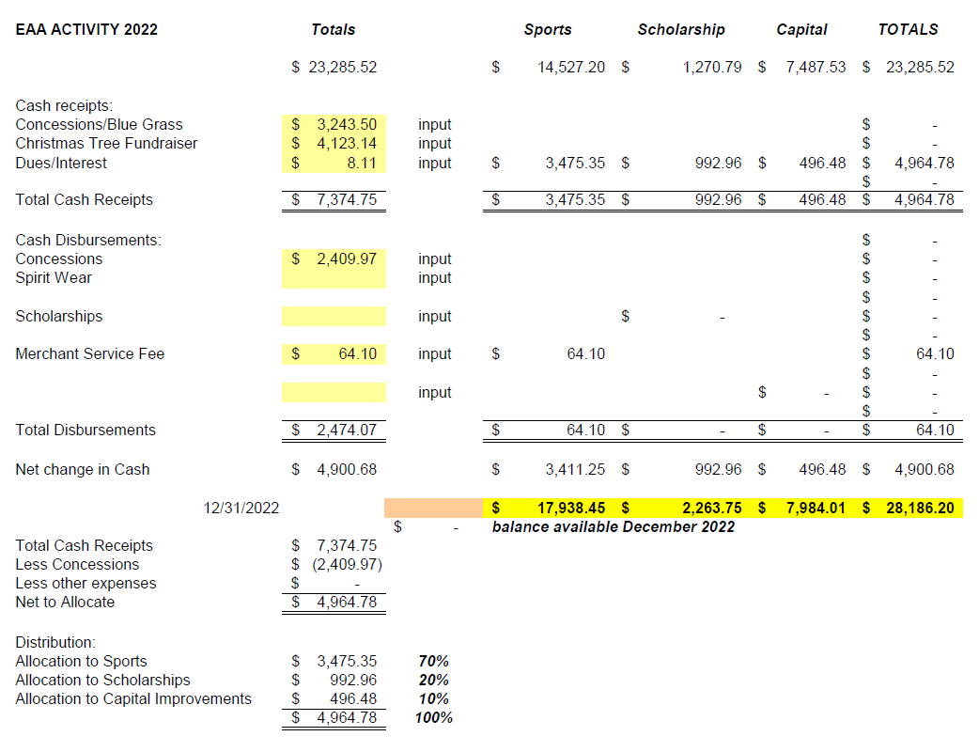
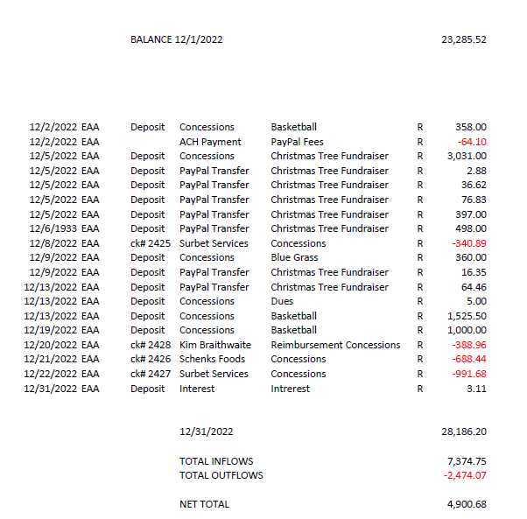

Motion to accept made by: Randy Trenary
Seconded by: Dr. Bishiop
Motion passed, treasurer’s report accepted
Committee Reports:
- Bluegrass
  - There are two concerts left for this year. Please share when you see Randy post. We need as many people as possible to attend for us to make a profit.
- Scholarship
  - To early to discuss
- Concessions
  - We will increase prices in the spring for the concession stand food items.
  - Motion made by Randy Trenary
  - Second: Dr. Bishop
- Apparel
  - No Report tonight

Old Business:
- Maryam asked if there was a plan B for the Cash Party. Discussed the success of the FFA calendar type fundraisers. Concerns of profit if not able to do Cash Party. Would like scholarships to be at $10k.
  - Maria will speak with Enders to see if they
- Meeting to discuss the installation of lights on softball and baseball fields, upgrade to football and parking lot will be at the conclusion of the next EAA meeting. The vendor, in which all VA schools use, will be in attendance.
New Business:
No new business

Recording Secretary: Jamie Sansom
Adjournment: Motion to adjourn made by Randy Trenary and seconded by Sherry Mayo and adjourned at 6:10 p.m.
Next meeting: 2/12/22
Future meetings: 3/13/23, 4/10/23, 5/8/23

