January 8, 2023
6:00 pm
CCHS Cafeteria

Attendance: Jamie Sansom, Karen Russell, Kathy Paskel, Margaret Kennedy, Steve Fox, Jeff Parker, Tiffany Roper, Wayne Foltz, Kim Braithwaite, Debbie Hardesty, Kim Arthur

- Call to Order - meeting was called to order at 6:01 p.m.
- Secretary’s minutes
Motion to accept made by: Steve Fox
Seconded by: Kathy Paskel

- Treasurer’s report

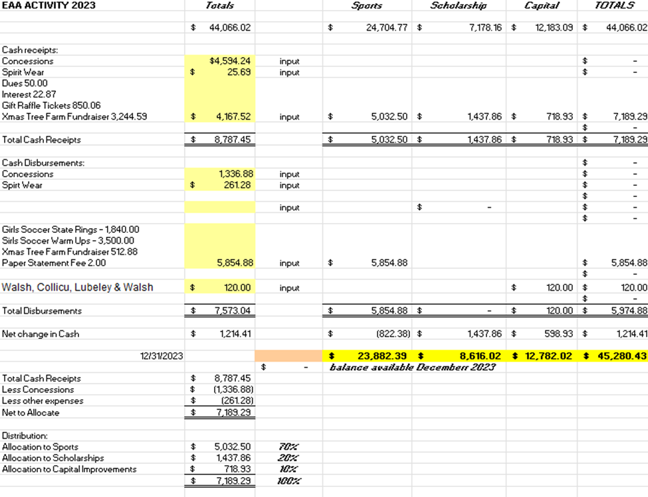
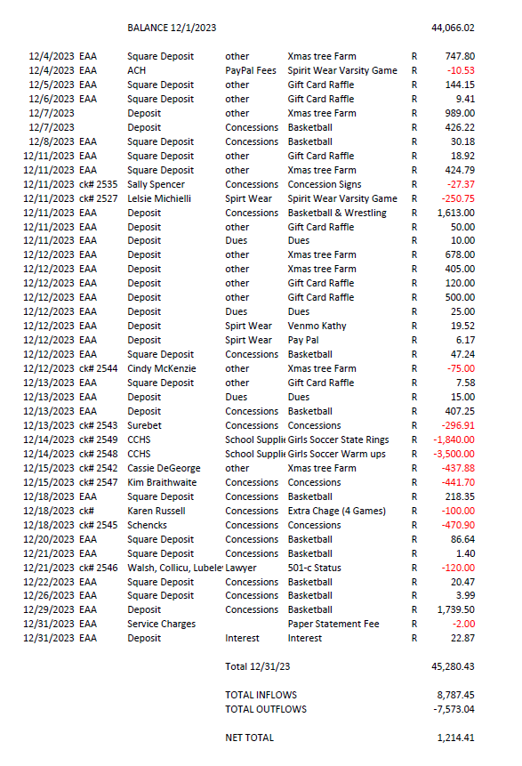
Motion to accept made by: Tiffany Roper
Seconded by: Margaret Kennedy

Committee Reports:

- Scholarship - Scholarship information will be sent out the end of January
- Concessions - Everything is going great, no issues.
- Apparel - Moved apparel from football to the High School and they plan to set up at a few more games.
- Fundraising - Nothing at this point

Old Business:
- Gift Card Raffle Drawing was a success Congratulations to Carolyn Lynch
- Coach Hawkins was approved for $3500 for warmups they will purchase tops and bottoms for 40 girls which includes JV and Varsity
- The 501c3 is still being worked on
- We paid for half of the girls soccer state rings $1850
- Cheerleading sent a Thank you card for the purchase of their pom poms

New Business:
- Jeff Parker the Varsity softball coach is requesting two sets of uniforms 18 uniforms per set. He is asking for $1800 to purchase these uniforms.
  - Motion approved: Kathy Paskel
  - Seconded by Margaret Kennedy
- Congratulations to the girls and boys swimming teams for a great season and good luck to those going to states.
Recording Secretary: Jamie Sansom
Adjournment: Motion to adjourn made by Kim Arthur and seconded by Steve Fox and adjourned at 6:13 p.m.
Next meeting: 2/12/24
Future meetings: 3/11/224, 4/8/24, 5/13/24

