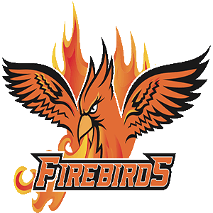 Falls Lake Academy Flight Booster Club Minutes
May 18, 2022

Mission Statement
The Athletic Booster Club’s goal is to support all FLA athletic programs by promoting funding for areas not fully covered by the school. The areas we focus on are uniforms, field rentals, coaches’ stipends, officials and miscellaneous equipment. The Booster Club works diligently with school administration and the Athletic Director as well as the many parent volunteers. By supporting the athletic program financially, we strive to allow our student athletes the best experience possible her at Falls Lake Academy Charter School.

ATTENDEES
ADs – Weston Pearson & Karen Teague
HS Vice President – Lisa Watkins MS Vice President – Catherine Kendrick
Coach May
Carrie Tidd
INTRODUCTION
Lisa Watkins began the meeting at 6:06pm, meeting was held at FLA HS Lobby.

AGENDAS
Bank Account Status: Beginning Cash Balance at Union Bank: $12,458.25
- Income – Deposits
  - 4/6 – Deposit +4,779.00
  - 4/25 – Deposit/Venmo +130.04
  - Total Income/Deposits: $4,909.04
- Expenses
  - 4/4 SGCC Golf Tournament -1,534.00
  - Total Expenses -$1,534.00
- Ending Balance: $15,626.48

Fundraising Dates on Calendar
- Fundraiser ideas for next year:
  - Vendor Fair & Food Trucks
  - Concessions for PTA Trunk or Treat & for Hit-a-thon fundraiser
  - Golf Tournament if Chris Teague would like to set up again
  - Snap Raise Donations (idea brought up from Coach May)
Miscellaneous
- New officers for the 2022-2023 school year:
  - President – Lisa Watkins
  - HS Vice President – Carrie Tidd
  - MS Vice President – TBD
  - Treasurer – Tracy Holcombe
  - Secretary – Catherine Kendricks
- Sports Passes & Sponsorship Packages approved
Updates
- MS Spring sports wrapped up a wonderful year of sports and look forward to being part of a conference next school year! MS Awards Night went great!
- HS Spring sports finishing up – Baseball & softball won conferences and made it to the 2nd round of playoffs. Women’s Soccer made playoffs for the first time in school history and advanced to 2nd round. Men’s golf team qualified for regionals even with numerous injuries to the team. HS Awards night is tomorrow night!

NEXT MEETING – August 17th @ 7pm HS Lobby

