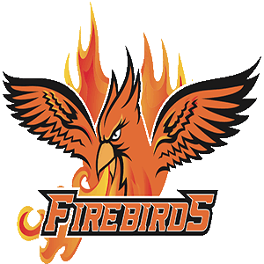 Falls Lake Academy Flight Booster Club Minutes
April 20, 2022

Mission Statement
The Athletic Booster Club’s goal is to support all FLA athletic programs by promoting funding for areas not fully covered by the school. The areas we focus on are uniforms, field rentals, coaches’ stipends, officials and miscellaneous equipment. The Booster Club works diligently with school administration and the Athletic Director as well as the many parent volunteers. By supporting the athletic program financially, we strive to allow our student athletes the best experience possible her at Falls Lake Academy Charter School.

ATTENDEES
ADs – Weston Pearson & Karen Teague
HS Vice President – Lisa Watkins
HS Treasurer – Tracy Holcombe

INTRODUCTION
Lisa Watkins began the meeting at 7:02pm, meeting was held at FLA HS Lobby.

AGENDAS
Bank Account Status: Beginning Cash Balance at Union Bank: $11,648.57
- Income – Deposits
  - 3/8 – Deposit +868.00
  - 3/25 – Deposit +248.00
  - Total Income/Deposits: $1116.00
- Expenses
  - 3/4 Food Lion -70.36
  - 3/25 Food Lion -73.77
  - 3/30 Sam’s Club -162.19
  - Total Expenses -$306.32
- Ending Balance: $12,458.25

Senior Gifts
- Reach out to Grey Johnson (Johnson-Lambe about backpack)
- Gifts – backpack, candy, gift cards, chick-fil-a lunch

Updates
- MS Spring sports rolling right along. All sports doing real well.
- HS Spring sports rolling right along. Men’s golf had some setbacks with injuries. Softball and baseball battling for conference title. Women’s Soccer battling to secure a home playoff game.

NEXT MEETING – May 18th @6pm HS Lobby (discuss sports passes and athletic sponsorships)

