Lady Warrior Player of the Week Awards
Week #10
Freshman Arianna Kling
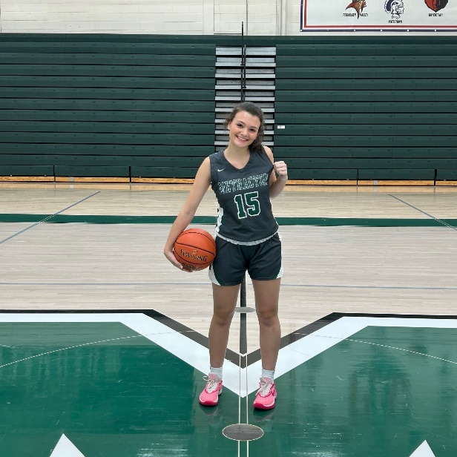
Player of the Week 10 is Freshman Arianna Kling. Arianna had a great year at the JV level finishing third on the team in scoring at 4.2 ppg and third in assists with 16. She also led the team in getting the free throw line 63 times with her relentless hard drives to the basket. Arianna plays each play harder then she did the previous one.

Season Winners
Week 1 Junior Abby Arnold
Week 2 Sophomore Avery Kenney
Week 3 Senior Courtney Freese
Week 4 Sophomore Molly Schwanholt
Week 5 Junior Abby Arnold
Week 6 Freshman Abby Masotta
Week 7 Freshman Adhara Reddy
Week 8 Sophomore Sydney Hockenbrock
Week 9 Junior Jenna Kaufman

